

**CONTRACEPTIVE LOGISTICS**

**MANAGEMENT**

**INFORMATION SYSTEM**

User Manual

Population Welfare Department

Punjab



*Draft*

March 2015

# Table of Contents

[Table of Contents 3](#_Toc414545586)

[List of Acronyms 7](#_Toc414545587)

[Overview 9](#_Toc414545588)

[Background 9](#_Toc414545589)

[The Paper-based Logistics Management Structure in Pakistan 11](#_Toc414545590)

[Existing Reporting Structure 12](#_Toc414545591)

[Population Welfare Department (PWD) 12](#_Toc414545592)

[About Logistics Management Information System 14](#_Toc414545593)

[Assumptions 15](#_Toc414545594)

[System Requirements 15](#_Toc414545595)

[Browser Support 15](#_Toc414545596)

[Users and User Roles 17](#_Toc414545597)

[Guest User 18](#_Toc414545598)

[Authenticated Users 19](#_Toc414545599)

[District Store User 19](#_Toc414545600)

[Step-by-Step 21](#_Toc414545601)

[LMIS Homepage 21](#_Toc414545602)

[Logging into Contraceptive Logistics Management Information System 22](#_Toc414545603)

[cLMIS Homepage Menu 23](#_Toc414545604)

[Contact Us Tab 23](#_Toc414545605)

[Frequently Asked Questions Tab 24](#_Toc414545606)

[Changing Your Password 25](#_Toc414545607)

[Forgot Password 26](#_Toc414545608)

[Logging Out 26](#_Toc414545609)

[Dashboards 27](#_Toc414545610)

[Introduction 27](#_Toc414545611)

[Public Sector Dashboard 28](#_Toc414545612)

[Stock Out vs Over Stock 29](#_Toc414545613)

[Stock Issued vs Stock on Hand (SOH) in CW&S 30](#_Toc414545614)

[Consumption vs Average Monthly Consumption (AMC) 31](#_Toc414545615)

[Couple Year Protection (CYP) 32](#_Toc414545616)

[Couple Year Protection (CYP) Map 33](#_Toc414545617)

[Private Sector Dashboard 34](#_Toc414545618)

[Stock Out vs Over Stock 35](#_Toc414545619)

[Stock Issued vs Stock on Hand (SOH) in CW&S 36](#_Toc414545620)

[Consumption vs Average Monthly Consumption (AMC) 37](#_Toc414545621)

[Couple Year Protection (CYP) 38](#_Toc414545622)

[Couple Year Protection (CYP) Map 39](#_Toc414545623)

[Reports 41](#_Toc414545624)

[National Summary Report 42](#_Toc414545625)

[Stakeholder Summary Report 45](#_Toc414545626)

[Provincial Summary Report 47](#_Toc414545627)

[District Summary Report 50](#_Toc414545628)

[District Stock Yearly Report 53](#_Toc414545629)

[Stock Availability Report 54](#_Toc414545630)

[Non/Reported Districts 55](#_Toc414545631)

[Quarterly Reporting Rate 58](#_Toc414545632)

[Provincial Reporting Rate 59](#_Toc414545633)

[Projected Contraceptive Requirements 60](#_Toc414545634)

[Central/Provincial Warehouse Report 61](#_Toc414545635)

[Provincial Yearly Report 62](#_Toc414545636)

[Private Sector Yearly Report 63](#_Toc414545637)

[Public-Private Sector Report 64](#_Toc414545638)

[Maps 65](#_Toc414545639)

[Month of Stock Map 66](#_Toc414545640)

[Consumption Map 67](#_Toc414545641)

[Couple Year Protection Map 68](#_Toc414545642)

[CYP by Population Map 69](#_Toc414545643)

[Reporting Rate Map 70](#_Toc414545644)

[Graphs 71](#_Toc414545645)

[Comparison Graphs 72](#_Toc414545646)

[Simple Graphs 75](#_Toc414545647)

[LMIS Explorer 77](#_Toc414545648)

[Guest User 79](#_Toc414545649)

[Authenticated Users - District 81](#_Toc414545650)

[Dashboard 83](#_Toc414545651)

[Data Entry (Monthly Stock Consumption) 84](#_Toc414545652)

[Monthly Reports 87](#_Toc414545653)

[My Reports 87](#_Toc414545654)

[LMIS Explorer 88](#_Toc414545655)

[Requisitions 89](#_Toc414545656)

[New Requisition 90](#_Toc414545657)

[View Requisition 91](#_Toc414545658)

[PBS Reports 92](#_Toc414545659)

[Form - 14 92](#_Toc414545660)

[CLR - 11 93](#_Toc414545661)

[SPR - 1 94](#_Toc414545662)

[SPR - 2 95](#_Toc414545663)

[PWD - 3 96](#_Toc414545664)

[Provincial Reports 97](#_Toc414545665)

[SPR - 3 97](#_Toc414545666)

[Outlet-wise CYP Performance 98](#_Toc414545667)

[District-wise CYP Performance 99](#_Toc414545668)

[Stock Sufficiency Report 100](#_Toc414545669)

[District Reports 101](#_Toc414545670)

[SPR - 8 101](#_Toc414545671)

[SPR - 9 102](#_Toc414545672)

[SPR - 10 103](#_Toc414545673)

[SPR - 11 104](#_Toc414545674)

[CLR - 15 105](#_Toc414545675)

[Reports 106](#_Toc414545676)

[Maps 107](#_Toc414545677)

[Graphs 108](#_Toc414545678)

# List of Acronyms

|  |  |
| --- | --- |
| AJK | Azad Jammu and Kashmir |
| CW&S | Central Warehouse and Supplies |
| CYP | Couple Years of Protection |
| DDP | District Distribution Points |
| DOH | Department of Health |
| DPIU | District Project Implementation Unit |
| DPWO | District Population Welfare Office |
| FATA | Federally Administered Tribal Areas |
| FLCF | Fist Level Care Facility |
| FWC | Family Welfare Center |
| LHW | Lady Health Worker |
| LMIS | Logistics Management Information System |
| MoNHSR&C | Ministry of National Health Services, Regulations and Coordination |
| MSU | Mobile Service Unit |
| PLDO | Provincial Line Department Outlets |
| PPIU | Provincial Project Implementation Unit |
| RHS-A | Reproductive Health Services – A |
| RHS-B | Reproductive Health Services – B |
| RMP | Registered Medical Practitioners |
| SDP | Service Delivery Point |
| TB | Tuberculosis |
| TBA | Traditional Birth Attendants |
| USAID | United Stated Agency for International Development |
| WMS | Warehouse Management System |

|  |  |
| --- | --- |
| Overview | **1** |
| of Contraceptive Logistics Management Information System | |

This *User Manual* provides step-by-step instructions which help you get started with Logistics Management Information System (LMIS). It provides guidelines on application features to manage logistics data. This user guide is organized according to the logical flow of LMIS features and describes tasks in the same order you can use while working with the application.

|  |  |
| --- | --- |
| *C:\Users\isbah.zulfiqar\Desktop\1382615592_file_edit.png* | **Before You Begin...**  It is recommended to have a working internet connection for web-access to the application in order to review the application side-by-side when reading this manual. |

## Background

USAID | DELIVER PROJECT Pakistan has been tasked by the Government of Pakistan with implementing a Logistics Management Information System (LMIS) using a web-based approach. After several months of thorough consultations with all stakeholders from the public and private sectors, the Project adapted and enhanced the web-based application from the Bangladesh model. During the enhancement process, LMIS was contextualized to the local stakeholder structure and devolution.

LMIS was launched by the Prime Minister of Pakistan on July 2011 as the public sector’s first Logistics Management Information System.

LMIS has the flexibility to integrate other health commodities in addition to contraceptives. The Project has integrated other health products to meet the provincial integrated commodity management requirements. In addition to the public sector, this application is also able to record contraceptives national sales data of private sector. The system is able to cater to district level reporting by aggregating facility level data through paper-based reports. In Release-2, LMIS has been enhanced for facility level reporting on logistics indicators for each district along-with district store commodities status. To strengthen reporting and visibility of private sector contraceptives, a district level interface has been incorporated in LMIS which will enable provincial and regional health and population departments to see the contribution of the private sector in their respective geographical areas at both the provincial and regional level.

In order to implement the LMIS nationwide, the Project needed to train the expected users of the system. The prescribed training provides knowledge and skills required to enter data into the web-based LMIS. LMIS played a significant role in improving stock monitoring at the district and sub-district level.

The Central Warehouse and Supplies (CW&S) is a national repository for contraceptive commodities. All public sector stakeholders at the district level raise integrated requisition requests to the CW&S for contraceptive supplies. The Project is providing the transportation support from CW&S to the district stores.

Timely and accurate data entry and submission of a monthly report at the district level are critical to the functioning of the LMIS. The data collected from the LMIS can then subsequently be used at each level of the supply chain to enhance informed decision making to meet service delivery demands. Utilization of the LMIS depends on the level of understanding of those trained on its various functionalities.

## The Paper-based Logistics Management Structure in Pakistan

There are different vertical programs in public health sector with varying commodity distribution systems for products such as lab equipment, anti-TB drugs and other essential medicines in addition to contraceptives. The verticality of the health system poses a unique challenge in Pakistan. Another complexity includes the fact that some systems are operating under a pull system whereas others are referred to a push system to deliver products.

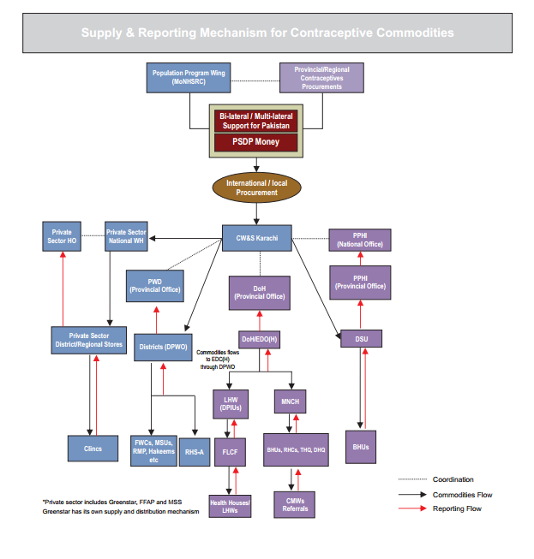

Some programs distribute directly from the central warehouse to the district stores such as for contraceptive while others flow through different supply chain levels. There are linkages among various stakeholders at national, provincial and district levels for requisitioning, delivery and storage of contraceptives. Any LMIS intended to provide national level stock status and consumption data must accommodate all stakeholders and their linkages.

At the public sector level, there are three main stakeholders; Ministry of National Health Services, Regulations and Coordination (MoNHSR&C), Population Welfare Departments in each province and region and Departments or Directorates of Health in each province and region. Mainly, there are three primary healthcare components of DOH which includes; Static Health Facilities, Lady Heath Workers (LHW) program and Mother & Neo-natal Child Healthcare (MNCH) program. Although there are vertical programs in DOH at the provincial levels, these programs are functionally integrated at the district level. However, a reasonably good level of coordination exists between the Health and Population Welfare Departments.

## Existing Reporting Structure

### Population Welfare Department (PWD)

In the PWD reporting structure, all Service Delivery Points (SDPs) report to their respective district/area/agency and the DPWO compiles as well as sends the CLR-15 report to provincial/regional headquarters. Each Provincial/Regional Headquarter and ICT prepares the CLR-11, which is then sent to the Federal office for preparation of the monthly contraceptive performance report. The CW&S in Karachi sends the CLR-8 monthly for review at the federal level. The CLR-8 provides stock status of commodities lying in CW&S.

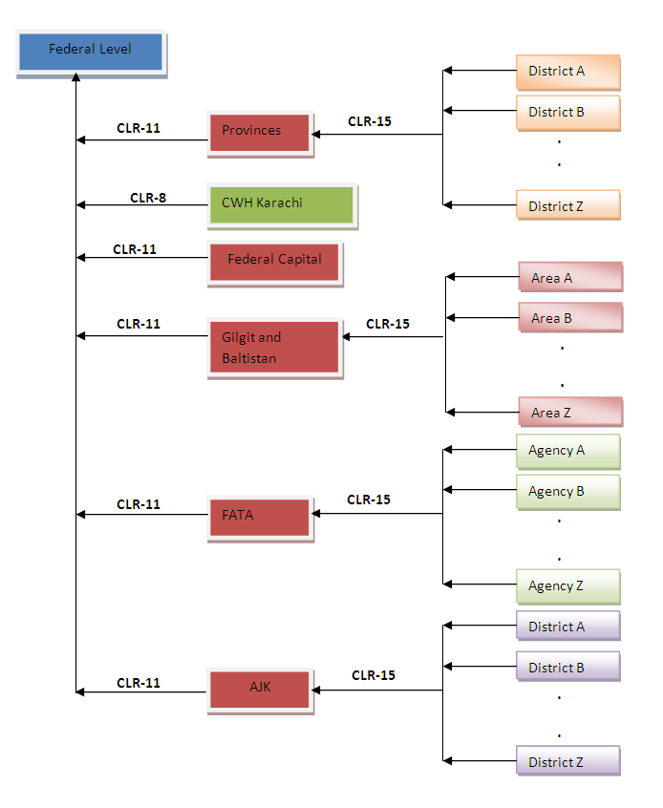

**Figure-1**: A Flowchart showing flow of data from district to federal level in Population Welfare Department.

The following facilities are being managed by district population welfare department which provides contraceptives and supervises activities of following service delivery points:

1. FHC (Family Health Clinic) / RHS-A (Reproductive Health Services – A)
2. FWC (Family Welfare Center)
3. RHS-B (Reproductive Health Services – B)
4. MSU (Mobile Service Unit)
5. Social Mobilizers
6. PLDs (Provincial Line Department Outlets)
7. RMPs (Registered Medical Practitioners)
8. Hakeems (Traditional healers using mostly herbal remedies)
9. Homeopaths
10. DDPs (District Distribution Points)
11. TBA (Traditional Birth Attendants)
12. Counters

## About Logistics Management Information System

The draft 2010 population policy clearly emphasizes the importance of an operationally effective logistics management information system (LMIS). A paper-based logistics information system was unable to accurately track the contraceptive stock status at various levels of the supply chain from CW&S to the facility level. Inaccurate reporting of data results in unrealistic forecasting and procurement when trying to work within an entire logistics system. In identifying the need for accurate essential logistics data for decision making, the Ministry of National Health Services, Regulations and Coordination (MoNHSR&C) requested the Project to replace the paper-based system to ensure an effective contraceptive supply chain.

The USAID | DELIVER PROJECT is providing technical assistance to the MoNHSR&C to strengthen the logistics system and improve overall supply chain management. During the years 2008-2009, a series of consultative meetings were held between the Ministry and the Project to access the requirements of the MoNHSR&C. One of the most important areas which requires immediate attention is enhanced data visibility to ensure improved product availability.

### Assumptions

This user manual assumes that you already have Contraceptive Logistics Management Information System accounts as per your geographical level and role. This user manual also assumes that you are familiar with the basic web-application account login procedures.

### System Requirements

The Contraceptive Logistics Management Information System is accessible from any Desktop PC, Mac, or Linux computer with Internet access and a supported Web-browser.

### Browser Support

The following browsers and later versions fully support cLMIS standard view:

* Mozilla Firefox (Windows, Mac, Linux)
* Google Chrome (Windows, Mac, Linux)
* Netscape (Windows, Mac, Linux)
* Safari (Mac)
* Internet Explorer 9 and above (Windows)

|  |  |
| --- | --- |
| Users and User Roles | **2** |
| of Contraceptive Logistics Management Information System | |

This chapter explains the overview of the user roles of Contraceptive Logistics Management Information System. The web-based application results in the LMIS system contextualized to fit local stakeholder structure and the devolution of health and population programs to provincial governments. The system brings in district-level reporting by aggregating facility-level data through paper-based reports. With a unified system for reporting and requisitioning, the LMIS system is able to integrate information from all levels and sectors. The web-based LMIS can be accessed at <http://lmis.gov.pk>.

In order to log on to the system, the user requires a username and password. Once successfully logged in, the user is directed to the relevant dashboard.

In order to obtain LMIS data and reports, the user must successfully login with his/her username and password. System users are defined by relevant stakeholders and the level in the supply chain they represent. For example, Population Welfare Department users work under Provincial PWD and District Population Welfare Officer.

The following table includes the activities that various users will be able to perform once they login:

*Stakeholder and level specific activities users can perform in cLMIS.*

|  |  |  |  |
| --- | --- | --- | --- |
| **Activity** | **Level** | | |
| **Central\*** | **District\*\*** | **Guest** |
| Data Entry |  |  |  |
| Requisitions |  |  |  |
| Inventory Management |  |  |  |
| Reports |  |  |  |
| Graphs |  |  |  |
| Maps |  |  |  |

*\* The Central Warehouse and Supplies will be responsible for entering all central level stock status updates into the LMIS.*

**Users and User Roles**

The Contraceptive Logistics Management Information System Users are basically store operators that manage and record the inventory and stock transactions. Each geographical level entails different user roles associated with their warehouse/store operations.

## Guest User

The Guest user can be any web user with the following capabilities:

|  |  |
| --- | --- |
| **Feature** | **Capabilities** |
| **Dashboard** | View public sector and private sector dashboards. |
| **LMIS Explorer** | View monthly store/facility consumption reports using LMIS explorer. |
| **Reports** | View logistics analysis in tabular formats. |
| **Maps** | View logistics analysis on maps. |
| **Graphs** | View logistics analysis as graphs. |

## Authenticated Users

The Authenticated users can log in to cLMIS and perform assigned functions. Each user is assigned responsibilities based on the role and geographical level.

### District Store User

|  |  |
| --- | --- |
| **Feature** | **Capabilities** |
| **Dashboard** | View public sector and private sector dashboards. |
| **Requisitions (CLR-6)** | Add new requisition requests.  View requisition requests. |
| **Data Entry (Monthly Consumption Reporting)** | Enter new data in stock report.  View stock report for previous month. |
| **View Monthly Reports** | View monthly reports for the users own district as well as other district stores. |
| **Reports** | View logistics analysis in tabular formats. |
| **Maps** | View logistics analysis on maps. |
| **Graphs** | View logistics analysis as graphs. |
| **Others** | Change account password. |

|  |  |
| --- | --- |
| Step-by-Step | **3** |
| Process to using Contraceptive Logistics Management Information System | |

This chapter explains the step-by-step instructions on getting started with cLMIS. In this section, you will learn about:

1. The Contraceptive Logistics Management Information System Homepage.
2. Logging Into Contraceptive Logistics Management Information System.
3. Changing your account password.
4. What to do if you forget your password.
5. Logging Out of Contraceptive Logistics Management Information System.

## LMIS Homepage

The Logistics Management Information System has a single landing page for its three modules for Contraceptives, TB, and Vaccines Management Information System. Enter the URL <http://lmis.gov.pk> to access the application homepage.

Once the user enters the URL <http://lmis.gov.pk>, the homepage will appear. This homepage displays a basic introduction to the ‘Pakistan LMIS’.

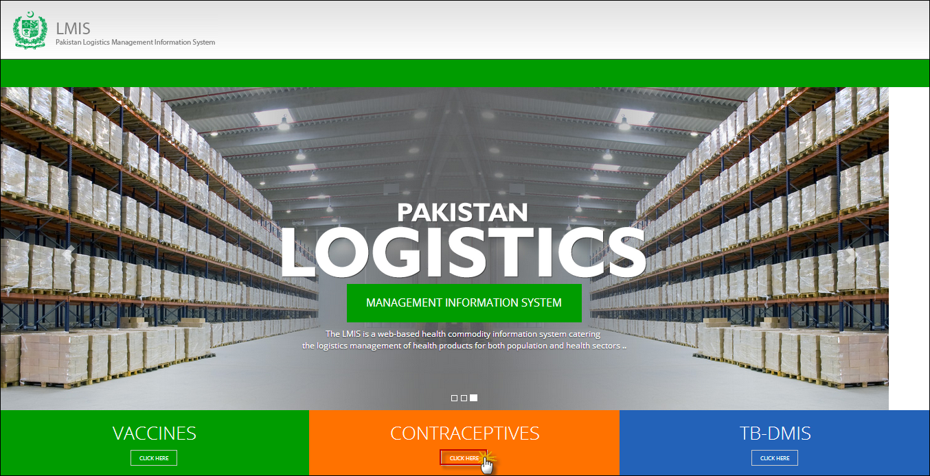

|  |  |
| --- | --- |
| *C:\Users\isbah.zulfiqar\Desktop\1382615592_file_edit.png* | **Before You Begin...**  It is recommended to use cLMIS with Google Chrome or Mozilla Firefox. Older generations of browsers are also supported; however, their use can lead to issues with on-screen formatting and display. |

Once you click **Contraceptives**, homepage for cLMIS will display.

## Logging into Contraceptive Logistics Management Information System

The cLMIS is a web-based reporting and inventory management application that makes it simple for beginners and experienced users to report logistics data, view performance and graphical reports as well as maps.

Users can also access contraceptive LMIS application directly by using <http://c.lmis.gov.pk> URL. Once the user enters the URL <http://c.lmis.gov.pk>, the homepage will appear. The homepage displays a basic introduction to the ‘contraceptive LMIS’.

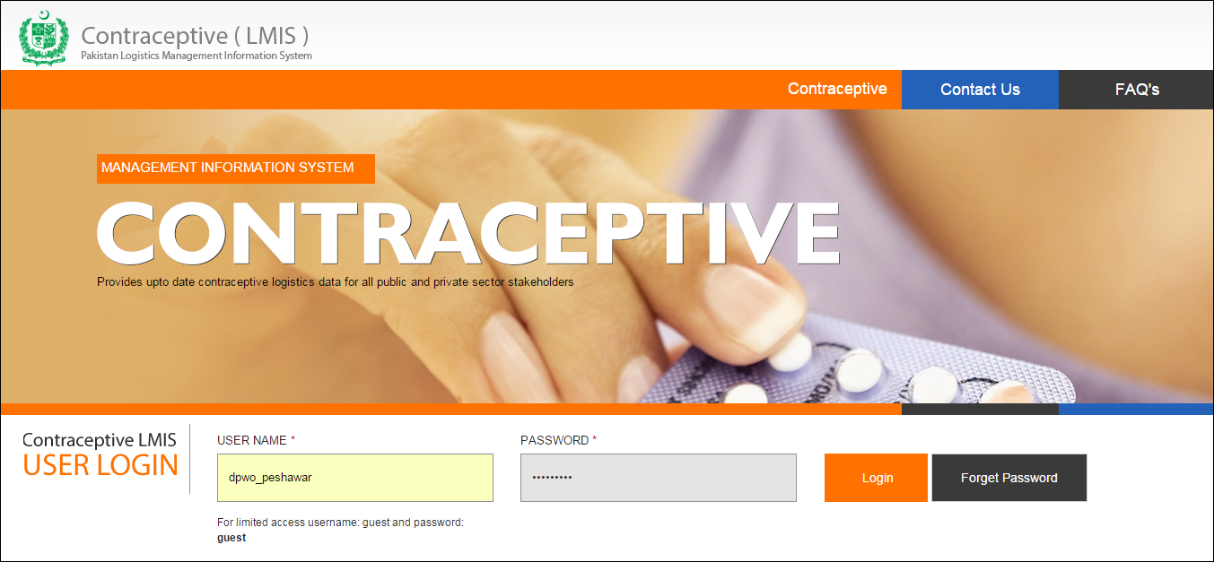

### cLMIS Homepage Menu

The available menu items can be found on the top of homepage screen. The components are displayed adjacently, as shown in the image below:



### Contact Us Tab

The **Contact Us** tab contains addresses, telephone numbers and email addresses (where available) for key personnel as a system communication list. Therefore, the user of LMIS will be able to see contact details of other stakeholders and can contact them as needed.

### Frequently Asked Questions Tab

The menu also contains a **FAQ’s** tab in order to provide guidance towards the most frequently asked and critical questions.

For logging in to Contraceptive LMIS area:

1. Go to <http://c.lmis.gov.pk>
2. Click the button **Click Here** on the Contraceptives tab.

cLMIS login page will be displayed.  
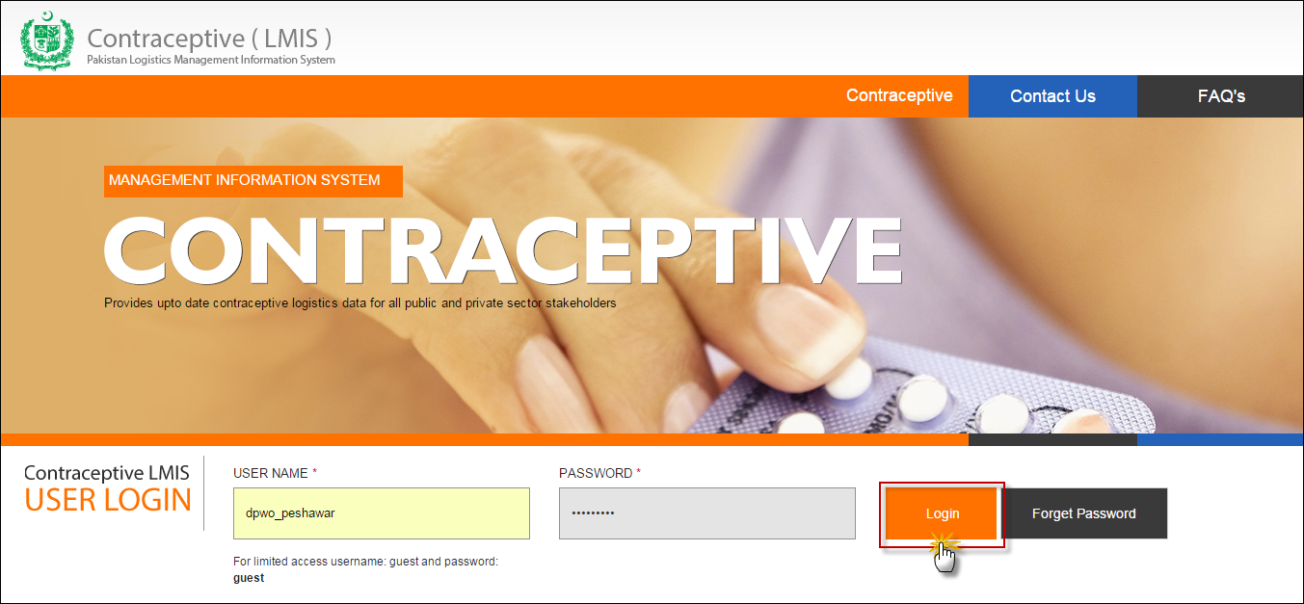

1. Specify the Username and Password provided to you by the Administrator.

|  |  |
| --- | --- |
| *C:\Users\isbah.zulfiqar\Desktop\1382615592_file_edit.png* | To login as a guest or anonymous user, you can simply provide the following credentials:  **Username**: guest **Password**: guest |

|  |  |
| --- | --- |
|  | You can change the password provided to you by the administrator. See “*Changing Your Password*” for details.  Never give out your password to anyone for security purposes. |

1. Click **Login**. The Contraceptive Logistics Management Information System Dashboard screen displays.

### Changing Your Password

To change your cLMIS password:

1. Login to cLMIS application.

The welcome screen displays.

1. On the right-side of the application, the user login name appears.
2. Under the login name, click **Change Password** as shown in the image below:  
   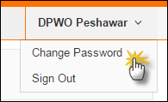
3. Specify the following:
   * **Old Password**: specify your old password.
   * **New Password**: specify the new password.
   * **Confirm New Password**: retype your password.

|  |  |
| --- | --- |
| *C:\Users\isbah.zulfiqar\Desktop\1382615592_file_edit.png* | Password Requirements  Your password must have a combination of a capital alphabet and one Numeric. |

|  |  |
| --- | --- |
|  | Never give out your password to anyone for security purposes. |

1. Click **Change Password**.  
   Your password will be changed successfully.

### Forgot Password

In case you have forgotten your password:

1. Open the cLMIS login page by entering the URL: <http://lmis.gov.pk>.
2. In the Login section, click **Forgot Password** as shown in the image below:  
     
   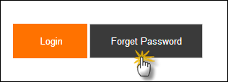

An alert message will be displayed.

Please contact [support@lmis.gov.pk](mailto:support@lmis.gov.pk)

1. The support team will provide you with a new password via email.

### Logging Out

When signed in, click **Sign Out** on the right-side of the application, as shown in the image below:  
  
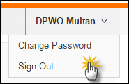

|  |  |
| --- | --- |
| Dashboards | **4** |
| for Contraceptive Logistics Management Information System | | |

This chapter explains the step-by-step instructions on the dashboard features that can be used by the Contraceptive Logistics Management Information system’s users.

## Introduction

Dashboard is a visual display of the most important analysis to achieve one or more objectives; consolidated and arranged on a single screen so the information can be viewed at a glance.

User can view following dashboards by default:

* Public Sector Stakeholders
* Private Sector Stakeholders

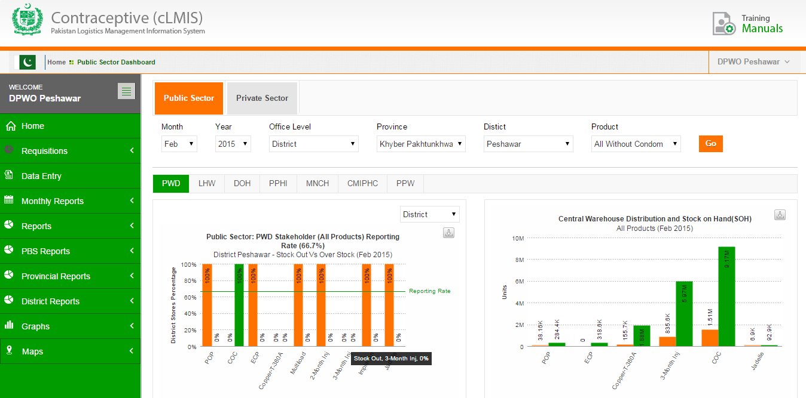

## Public Sector Dashboard

This dashboard allows users to quickly view analysis in a graphical manner for the selected public sector stakeholder.

* **Stock Out vs Over Stock**

This graph shows the stock out and over stock rates in district/sub-district (field) stores for different products. This also mentions the reporting rate on which this analysis is drawn.

* **Stock Issued vs Stock on Hand (SOH) in Central Warehouse**

This graph is showing the comparison between the issued stock and the stock on hand (SOH) for all products in the central warehouse.

* **Consumption vs Average Monthly Consumption (AMC)**

This graph is showing that the comparison between consumption and average monthly consumption of all products for the selected stakeholder and also shows the reporting rate on which this analysis is drawn.

* **Couple Year Protection (CYP)**

This graph is showing the product-wise CYP for the selected month.

* **Couple Year Protection (CYP) Map**

This map is showing the product-wise CYP for the selected month.

Users can apply following filters.

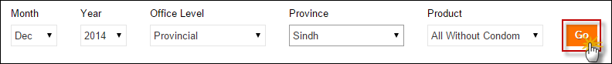

* **Month:** select the month from the drop-down list
* **Year:** select the year from the drop-down list.
* **Office Level:** select the Office Level from the drop-down list.
* **Province:** select the Province from the drop-down list.
* **District:** select the district for which you want to view report.
* **Product:** user can either select all products with or without condoms because the logistic analysis of condoms changes the maximum range of graphs to a level where analysis of other products is not shown properly.

Click **Go** to view Public Sector Dashboard.

### Stock Out vs Over Stock

Public Sector dashboard shows the stock out and over stock rates in district/sub-district (field) stores for different products. This also mentions the reporting rate on which this analysis is drawn. Users can view the comparison graph for stock out and over stock of products on the horizontal axis and District percentage on the vertical axis.

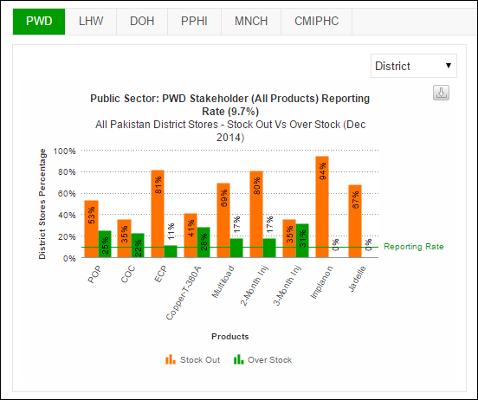

Users can also export charts in JPEG, PNG, PDF and SVG format.

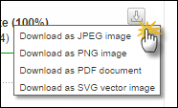

### Stock Issued vs Stock on Hand (SOH) in CW&S

Public Sector dashboard shows the comparison between the issued stock and the stock on hand (SOH) for all products in the central warehouse.

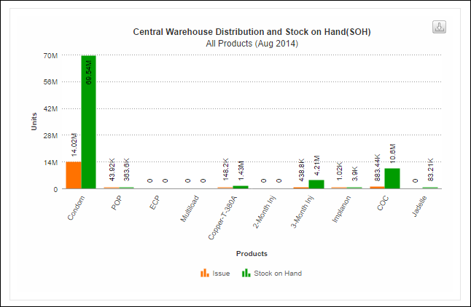

Users can also export charts in JPEG, PNG, PDF and SVG format.



### Consumption vs Average Monthly Consumption (AMC)

Public Sector dashboard shows the comparison between consumption and average monthly consumption of all products for the selected stakeholder and also shows the reporting rate on which this analysis is drawn.

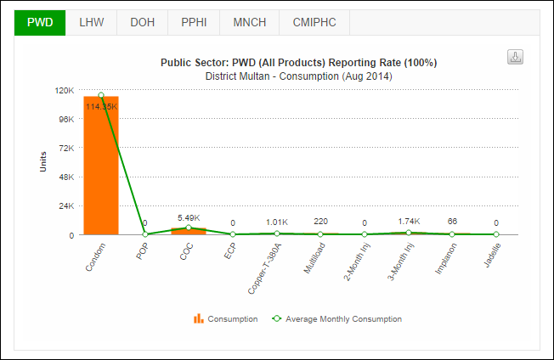

Users can also export charts in JPEG, PNG, PDF and SVG format.



### Couple Year Protection (CYP)

Public Sector dashboard shows the product-wise CYP for the selected month.

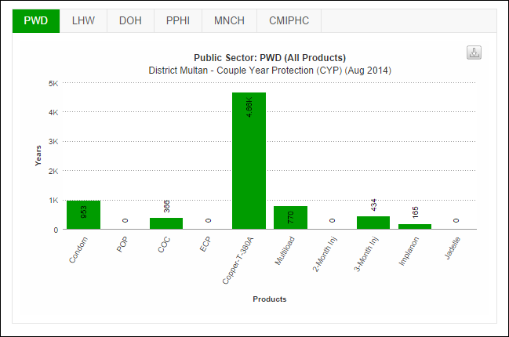

Users can also export charts in JPEG, PNG, PDF and SVG format.



### Couple Year Protection (CYP) Map

This map shows the product-wise CYP for the selected month.

Select the stakeholder and the product from the drop-down menu and click **GO.**

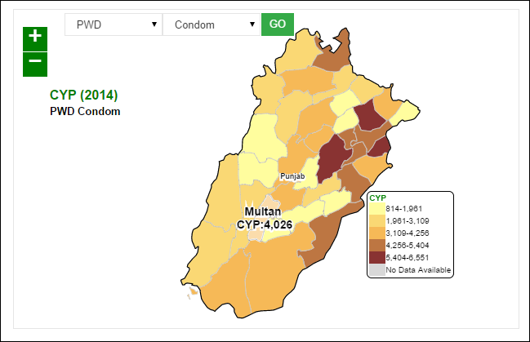

## Private Sector Dashboard

This dashboard allows users to quickly view analysis in a graphical manner for the selected private sector stakeholder.

* **Stock Out vs Over Stock**

This graph shows the stock out and over stock rates in district/sub-district (field) stores for different products. This also mentions the reporting rate on which this analysis is drawn.

* **Stock Issued vs Stock on Hand (SOH) in Central Warehouse**

This graph is showing the comparison between the issued stock and the stock on hand (SOH) for all products in the central warehouse.

* **Consumption vs Average Monthly Consumption (AMC)**

This graph is showing that the comparison between consumption and average monthly consumption of all products for the selected stakeholder and also shows the reporting rate on which this analysis is drawn.

* **Couple Year Protection (CYP)**

This graph is showing the product-wise CYP for the selected month.

* **Couple Year Protection (CYP) Map**

This map is showing the product-wise CYP for the selected month.

Users can apply following filters.



* **Month:** select the month from the drop-down list
* **Year:** select the year from the drop-down list.
* **Office Level:** select the Office Level from the drop-down list.
* **Province:** select the Province from the drop-down list.
* **District:** select the district for which you want to view report.
* **Product:** user can either select all products with or without condoms because the logistic analysis of condoms changes the maximum range of graphs to a level where analysis of other products is not shown properly.

Click **Go** to view Private Sector Dashboard.

### Stock Out vs Over Stock

Private Sector dashboard shows the stock out and over stock rates in district/sub-district (field) stores for different products. This also mentions the reporting rate on which this analysis is drawn. Users can view the comparison graph for stock out and over stock of products on the horizontal axis and District percentage on the vertical axis.

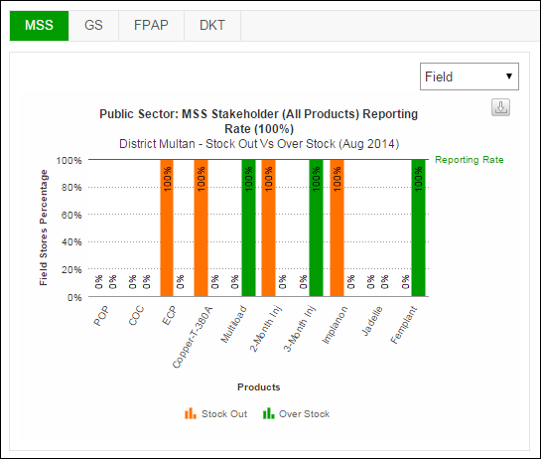

Users can also export charts in JPEG, PNG, PDF and SVG format.



### Stock Issued vs Stock on Hand (SOH) in CW&S

Private Sector dashboard shows the comparison between the issued stock and the stock on hand (SOH) for all products in the central warehouse.

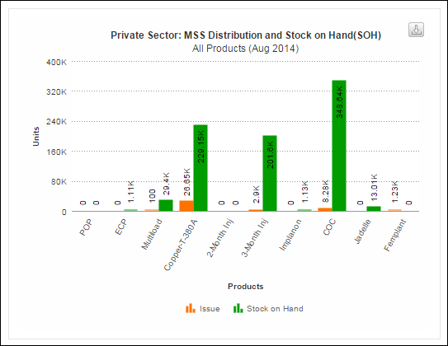

Users can also export charts in JPEG, PNG, PDF and SVG format.



### Consumption vs Average Monthly Consumption (AMC)

Private Sector dashboard shows the comparison between consumption and average monthly consumption of all products for the selected stakeholder and also shows the reporting rate on which this analysis is drawn.

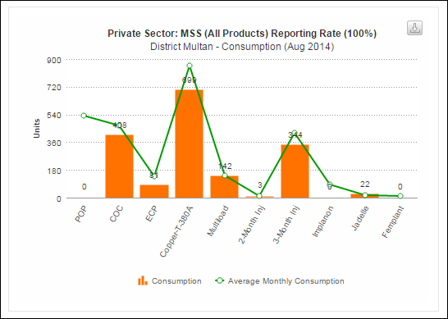

Users can also export charts in JPEG, PNG, PDF and SVG format.



### Couple Year Protection (CYP)

Private Sector dashboard shows the product-wise CYP for the selected month.

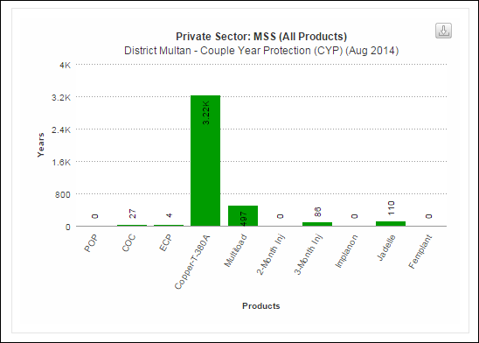

Users can also export charts in JPEG, PNG, PDF and SVG format.



### Couple Year Protection (CYP) Map

This map shows the product-wise CYP for the selected month.

Select the stakeholder and the product from the drop-down menu and click **GO.**

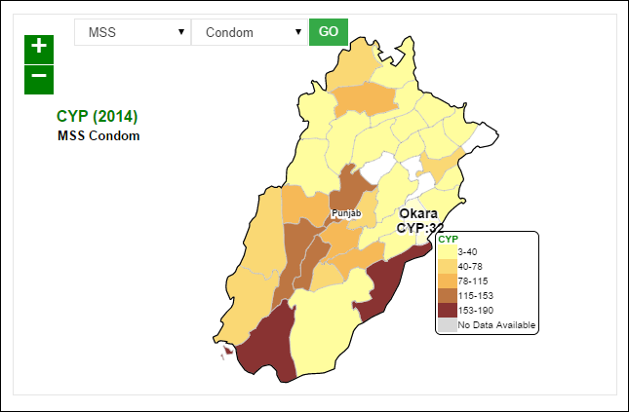

|  |  |
| --- | --- |
| Reports | **5** |
| for Contraceptive Logistics Management Information System | |

This chapter explains the step-by-step instructions on the report features that can be used by the Contraceptive Logistics Management Information system’s users.

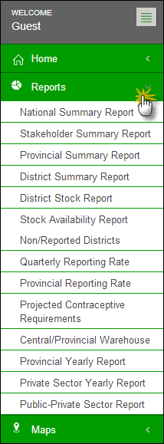When a user clicks the **Reports** tab, the application shows the list of all available reports. These reports include National, Provincial and District level Reports of both public and private sectors. It also includes Stakeholder Reports, Summary Reports, Field Reports and Stock Availability Reports. Quarterly and Provincial Reporting Rate has also been added in the list of available reports.

Click the **Reports** tab from the main menu to show a drop down list which includes a range of reports.

### National Summary Report

The National Summary Report provides periodic consumption, [average monthly consumption](http://115.186.136.214:8081/paklmis_final/plmis_src/reports/content-detail.php?title=pop_amc) (AMC), stock on hand (SOH), months of stock (MOS) and couple years of protection (CYP) by each commodity for a particular month. The data is summed up for all stakeholders as well as the public and private sector in each commodity to national level.

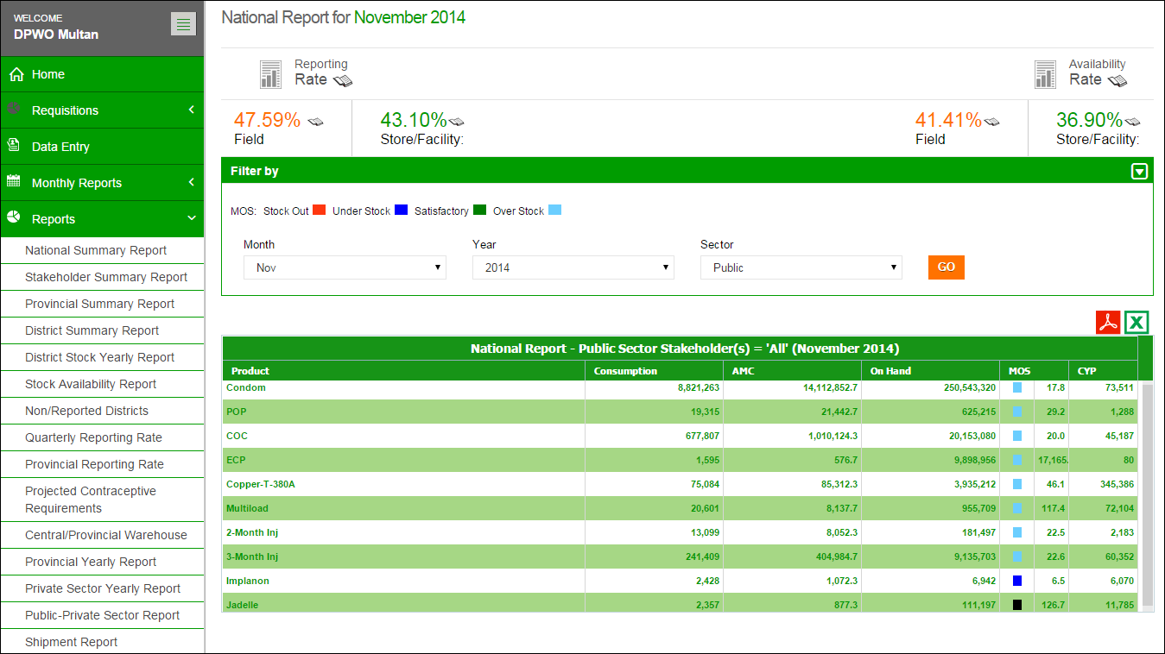

**Reporting and Availability Rates are displayed here**

**Table displays National Summary of each contraceptive**

**Use Filter options to filter data in the table below**

The national summary report not only provides the summary statistics but also opens up various options for users to explore further into the data through various links.

The Header bar displays the Reporting Rate i.e. rate of stores reported on the left side while on the right side, the Availability Rate i.e. rate of stock available is shown. You can click the  icon to open the Reporting Rate and Stock Availability rate reports directly.

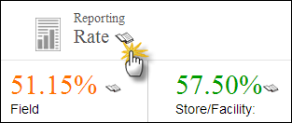Click on **Reporting Rate** to view the warehouse stores which have not reported for a particular month.

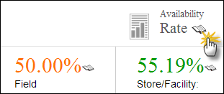Click on **Availability Rate** to view the stock availability rate at selected level i.e. National, Provincial and District level.

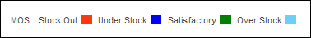MOS legends display the MOS Stock values. A black box represents an Unknown value.

**Filters**

You can use Month and Year filters to filter values based on Month and Year.

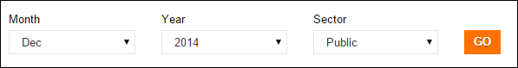

**Report Table**

* **Product**: It displays the list of products.
* **Consumption:** It displays the consumption data of contraceptives for the last reported month. The data for each product is the sum of all reporting levels.
* **Average Monthly Consumption (AMC):** It is calculated as average of aggregated consumption of the last three non-zero consumption months.
* **Stock on Hand (SOH):** It is the amount of product on hand in order to monitor stock positions and anticipate stock outs in advance.
* **Months of Stock (MOS):** It is the estimate of number of months the stock will last. This calculation is based on average monthly consumption.
* **Couple Years of Protection (CYP):** It is the estimated protection provided by contraceptive methods during a one-year period, based upon the volume of all contraceptives consumed during that period.

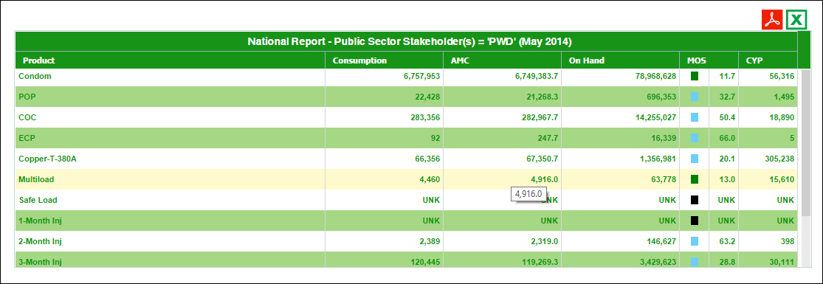

### Stakeholder Summary Report

This report provides information about periodic consumption and average monthly consumption of all stakeholders for a product.

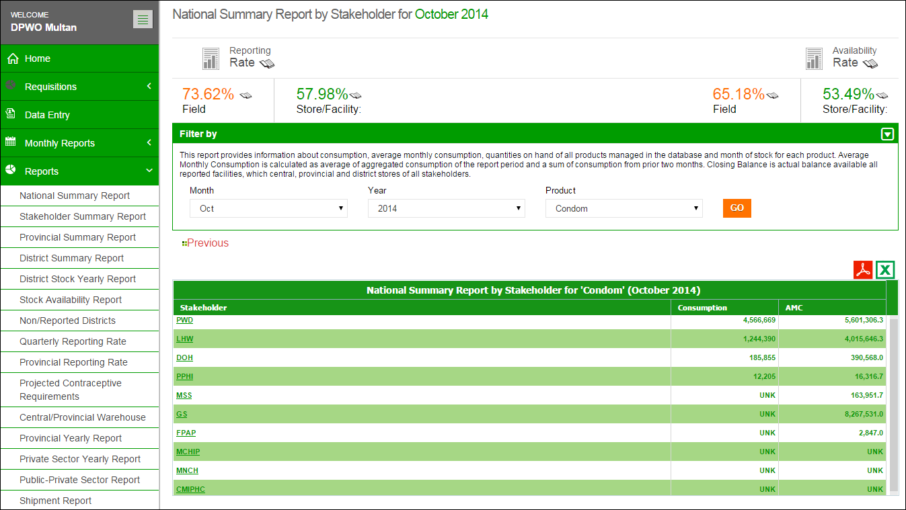

**Click GO.**

**Select Product**

Filtering options are also available on the basis of month, year and product as shown in the “Filter by” menu.

The Header bar displays the Reporting Rate i.e. rate of stores reported on the left side while on the right side, the Availability Rate i.e. rate of stock available is shown. You can click the  icon to open the Reporting Rate and Stock Availability rate reports directly.

Click on **Reporting Rate** to view the warehouse stores which have not reported for a particular month.

Click on **Availability Rate** to view the stock availability rate at selected level i.e. National, Provincial and District level.

**Filters**

You can use **Month**, **Year**, and **Product** filters to filter values in the table.



**Report Table**

* **Stakeholder:** It displays the list of identified stakeholders. By clicking on any of the stakeholders listed in Stakeholder Summary Report, the province wide summary of that particular stakeholder will appear.
* **Consumption:** It displays the consumption data of contraceptives for the last reported month. The data for each contraceptive is the sum of all reporting levels.
* **Average Monthly Consumption (AMC):** It is calculated as average of aggregated consumption of the last three non-zero consumption months.

**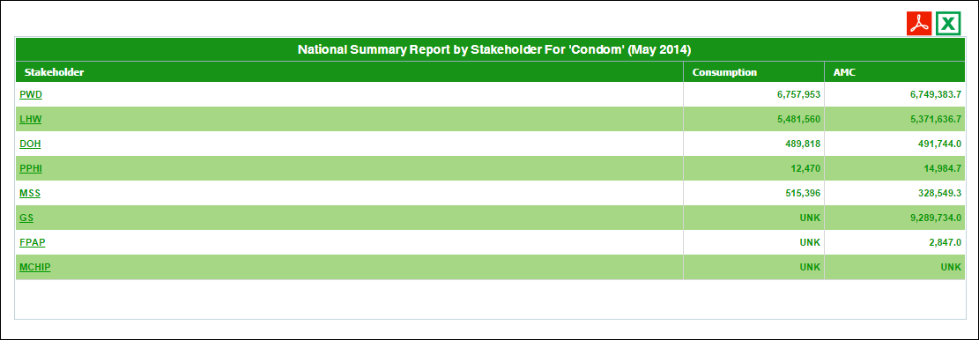**

### Provincial Summary Report

Provincial summary report provides periodic consumption, [average monthly consumption](http://115.186.136.214:8081/paklmis_final/plmis_src/reports/content-detail.php?title=pop_amc) (AMC), stock on hand (SOH), months of stock (MOS) and Couple Years of Protection (CYP) by each commodity for a particular month. The data is summed up for all stakeholders as well as the public and private sector in each commodity to provincial level.

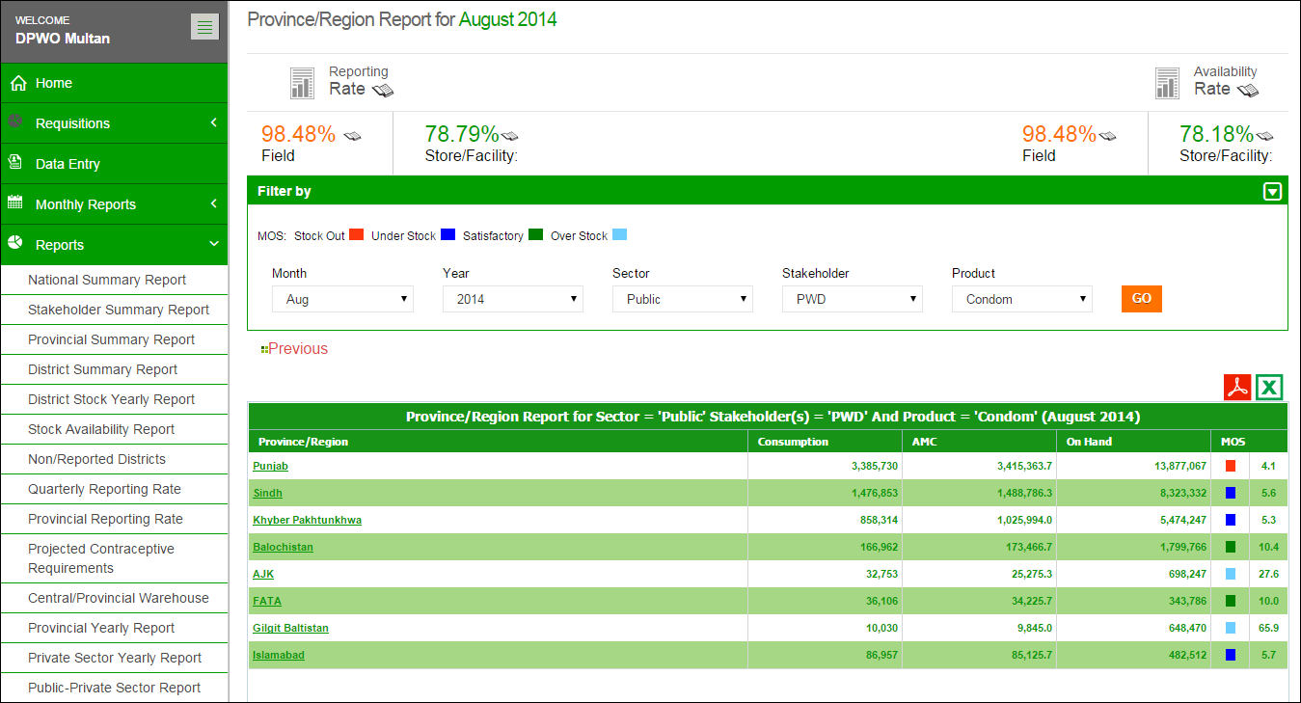

**Report for each province is displayed in the report table**

**Select Product & Stakeholder**

**Click GO.**

The provincial summary report not only provides the summary statistics but also opens up various options for users to explore further into the data through various links.

The Header bar displays the Reporting Rate i.e. rate of stores reported on the left side while on the right side, the Availability Rate i.e. rate of stock available is shown. You can click the  icon to open the Reporting Rate and Stock Availability rate reports directly.

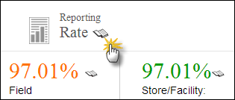Click on **Reporting Rate** to view the warehouse stores which have not reported for a particular month.

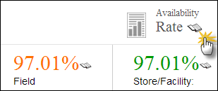Click on **Availability Rate** to view the stock availability rate at selected level i.e. National, Provincial and District level.

MOS legends display the MOS Stock values. A black box represents an Unknown value.

**Filters**

You can use Month, Year, Sector, Stakeholder and Product filters to filter values.



**Report Table**

* **Province**: It displays the list of provinces. By clicking on any of the provinces listed in Provincial Summary Report, the district wide summary of that particular stakeholder will appear.
* **Consumption:** It displays the consumption data of contraceptives for the last reported month. The data for each product is the sum of all reporting levels.
* **Average Monthly Consumption (AMC):** It is calculated as average of aggregated consumption of the last three non-zero consumption months.
* **Stock on Hand (SOH):** It is the amount of product on hand in order to monitor stock positions and anticipate stock outs in advance.
* **Months of Stock (MOS):** It is the estimate of number of months the stock will last. This calculation is based on average monthly consumption.

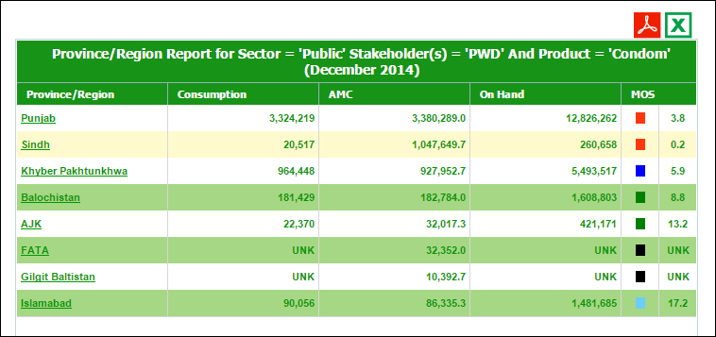

### District Summary Report

This report provides periodic consumption, [average monthly consumption](http://115.186.136.214:8081/paklmis_final/plmis_src/reports/content-detail.php?title=pop_amc) (AMC), stock on hand (SOH), months of stock (MOS) and couple years of protection (CYP) by each commodity for a particular month. The data is summed up for all public and private sector stakeholders for each commodity to the district level.

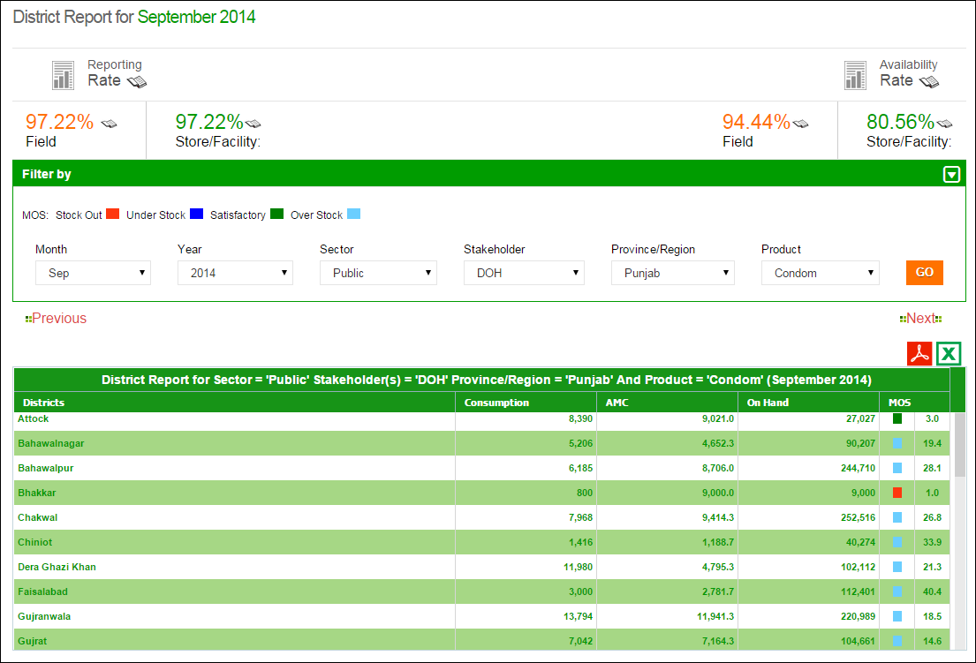

**Report for each district is displayed in the report table**

**Click GO.**

**Select Stakeholder, Province & Product**

The Header bar displays the Reporting Rate i.e. rate of stores reported on the left side while on the right side, the Availability Rate i.e. rate of stock available is shown. You can click the  icon to open the Reporting Rate and Stock Availability rate reports directly.

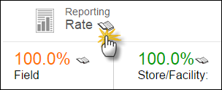Click on **Reporting Rate** to view the warehouse stores which have not reported for a particular month.

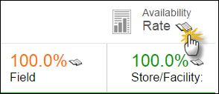Click on **Availability Rate** to view the stock availability rate at selected level i.e. National, Provincial and District level.

****MOS legends display the MOS Stock values.Black box represents Unknown value.

**Filters**

You can use Month, Year, Province/Region and Product filters to filter values in the table.



**Report Table**

* **Districts**: It displays the list of districts.
* **Consumption:** It displays the consumption data of contraceptives for the last reported month. The data for each product is the sum of all reporting levels.
* **Average Monthly Consumption (AMC):** It is calculated as average of aggregated consumption of the last three non-zero consumption months.
* **Stock on Hand (SOH):** It is the amount of product on hand in order to monitor stock positions and anticipate stock outs in advance.
* **Months of Stock (MOS):** It is the estimate of number of months the stock will last. This calculation is based on average monthly consumption.

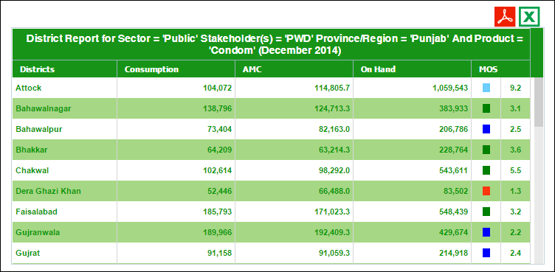

### District Stock Yearly Report

This report shows month wise stock issued or received for any stakeholder in a particular district of a province for the previous year. User is provided with a set of filters that are helpful to extract data by province, month, year, or stakeholder. Type filter provides an option to show received or issued stock.

**Select Province, Stakeholder, Product & Type**

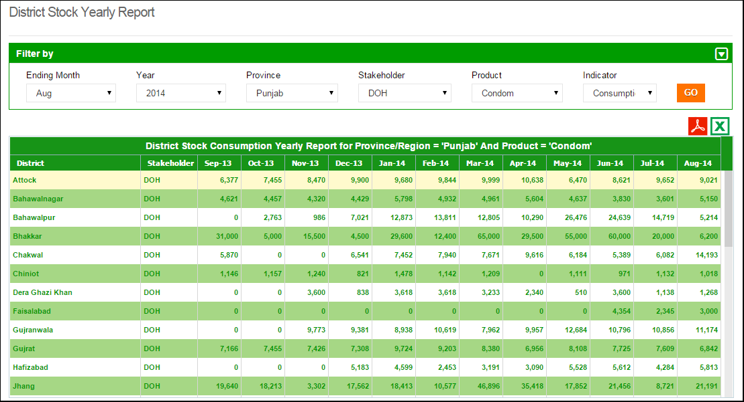

**Report for each district is displayed in the report table**

**Select Month & Year**

**Click GO.**

You can filter data on the basis of month, year, province, stakeholder, product and indicator. There are four indicators present which include:

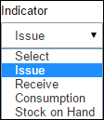**Issue:** Stock issued from district stores to health facilities (field)

**Receive:** Stock received from central warehouse Karachi

**Consumption:** Stock issued to the end users from health facilities in the district

**Stock on Hand:** Stock present in all stores (district and health facilities) in the district

### Stock Availability Report

The Stock Availability Report provides the availability rate and the months of stock for each store and facility. The availability rate for central warehouse, provinces and districts for a particular month by stakeholder can be filtered from the menu provided.

**Use Filter options to filter data in the table below**

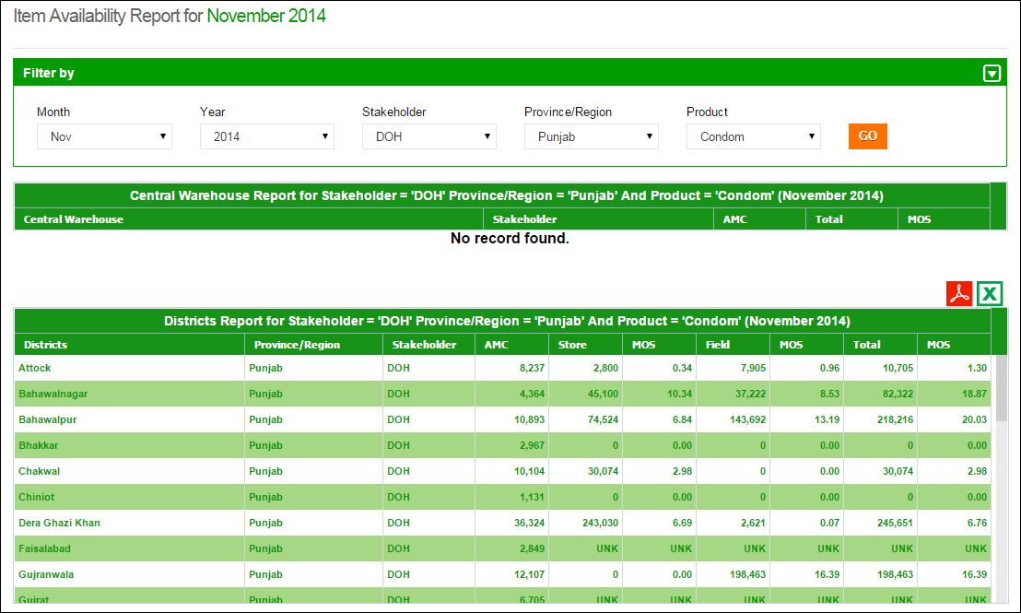

**Show filtered results of Districts.**

**Generate PDF\Excel**

**Select province.**

**Show filtered results of central warehouses.**

The report shows the in-country available stock based on filters applied at all levels of supply chain and stocks are also translated in months of stock calculated from Average Monthly Consumption. Separate months of stock for field and store are provided in addition to the aggregate for the two. In this report, only those stores appear which have reported for the period applied to view the report.

### Non/Reported Districts

The Non-reported Districts Report provides the reporting rate for provinces as well as districts (by stakeholders) which have not reported for a particular month. If “all” is selected from the option “stakeholder”, all district level stakeholders not reporting for a particular month will appear in the list. For example, a district name will appear twice if both DPIU and DPWO have not reported.

**Use Filter options to filter data in the table below**

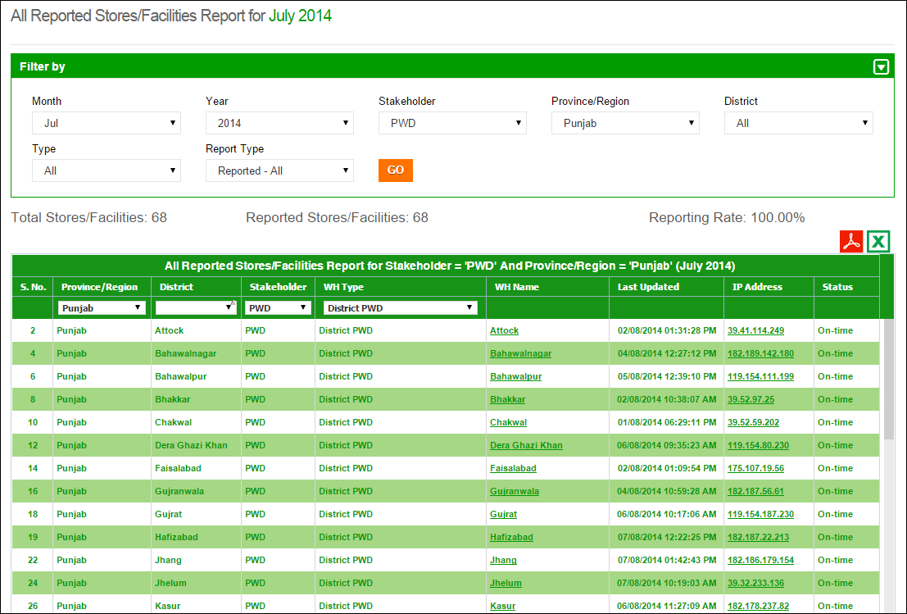

**Table displays non-reported stores data**

**Field Reporting Rate**

By selecting the type as **Field** in the filter, user can view the non-reported facilities in the field (by stakeholders) which have not reported for a particular month. If “all” is selected from the option “stakeholder” all stakeholders not reporting for a particular month will appear in the list.

**Use Filter options to filter data in the table below**

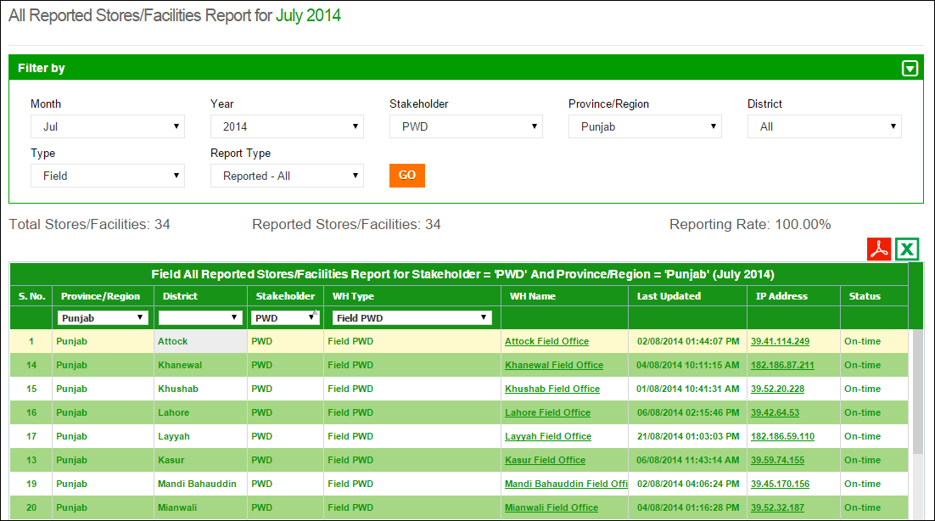

**Select Field**

**Table displays non-reported stores data in the field**

**District Reporting Rate**

By selecting the type as **District** in the filter, user can view the non-reported stores in the districts (by stakeholders) which have not reported for a particular month. If “all” is selected from the option “stakeholder” all stakeholders not reporting for a particular month will appear in the list.

**Use Filter options to filter data in the table below**

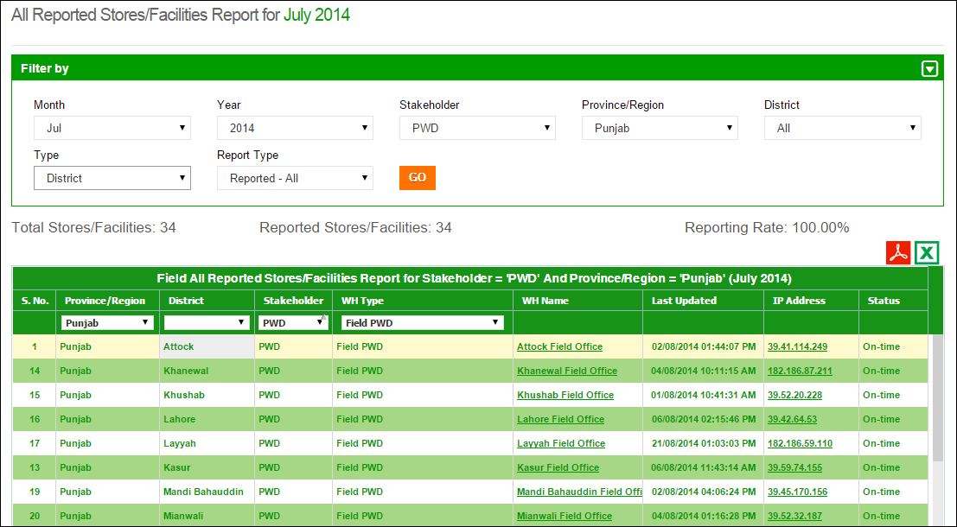

**Select District**

**Table displays non-reported stores data for districts**

### Quarterly Reporting Rate

By selecting the desired quarter of a year in the filter, user can view the reporting rate at the provincial level (by stakeholders) for each month of the quarter.

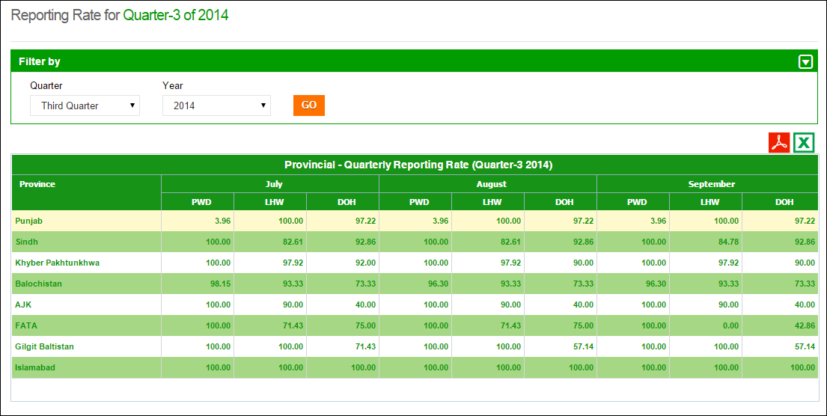

**Select Quarter & Year**

**Table displays the quarterly reporting rate for each province**

### Provincial Reporting Rate

This report shows the provincial reporting rates for particular public sector stakeholders i.e. PWD, LHW and DOH. User can filter report on the basis of month and year.

The filtered results of the stakeholders will be displayed in the form of district reporting rate, field reporting rate and total (overall) reporting rate.

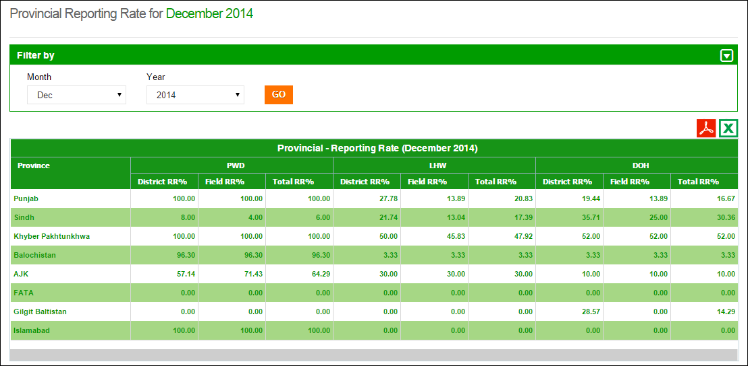

**Table displays the provincial reporting rate for each stakeholder**

**Select Month & Year**

### Projected Contraceptive Requirements

This report shows the projected contraceptive requirement for a selected product in each district based on the previous consumption of the product. User can select the ending month, year, demand for number of months, type, stakeholder and province to estimate the contraceptive requirement for each district. The report shows average monthly consumption (AMC), stock available in district store, field and sum of the two for the selected ending month. It also shows desired stock level for 3 months and the requested replenishment stock for the selected store.

**Select Sector, Stakeholder & Province**

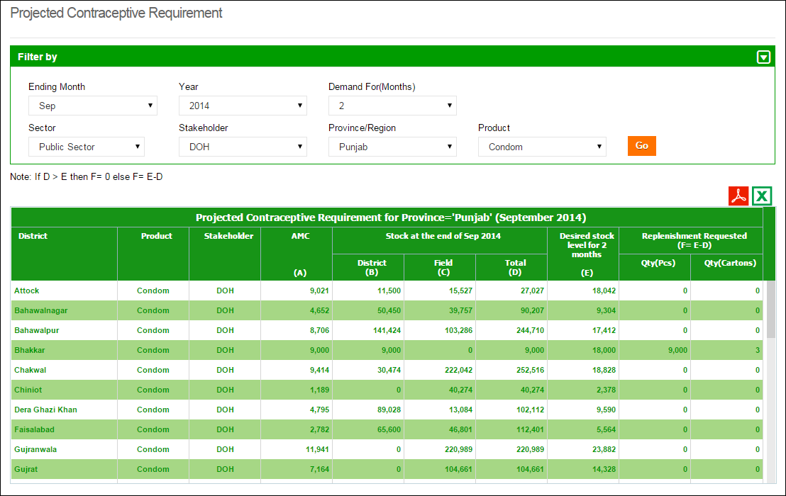

**Select Month & Year**

**Click Go**

### Central/Provincial Warehouse Report

This report shows the monthly values of different inventory indicators i.e. Issued, Stock on Hand and received stock of stakeholder’s central or provincial warehouse / stores. User can filter report on the basis of month, stakeholder and type of store i.e. Provincial and Central warehouse.

**Select Stakeholder, Indicator & Warehouse**

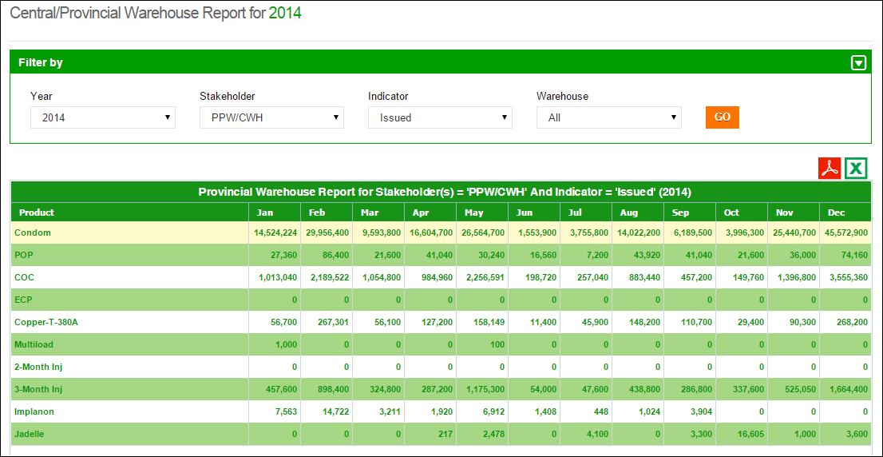

**Click GO**

**Select Year**

### Provincial Yearly Report

This report is to view provincial yearly report month for the selected stakeholder, indicator and year. There are five main indicators that can be viewed i.e. Issuance (Consumption), Couple Years of Protection (CYP), Stock on Hand and Received (District and Field). This is aggregate of the selected indicator from district and field. User can filter report on the basis of stakeholder and Province/Region.

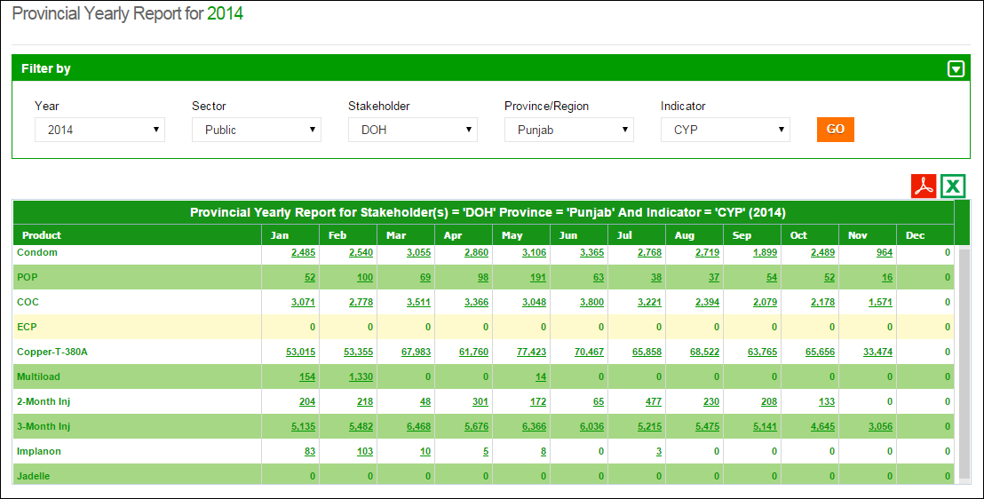

**Select Year**

**Click GO**

**Select Stakeholder, Province & Indicator**

### Private Sector Yearly Report

This report shows the monthly values of different inventory indicators i.e. Consumption, Stock on Hand and received stock for private sector stakeholder’s warehouses/stores in a particular month. User can filter on the basis of month, indicator and stakeholder.

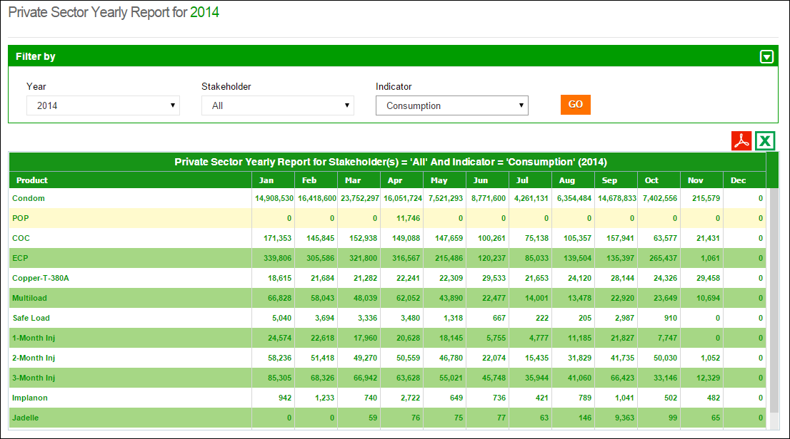

**Click GO**

**Select Stakeholder & Indicator**

**Select Year**

### Public-Private Sector Report

This report is to view the public and private sector share at National, Provincial, District and Field level on some indicators i.e. Consumption, AMC, Stock on Hand and MOS. User can filter on the basis of month and geographical levels i.e. National, Provincial, District and Facility.

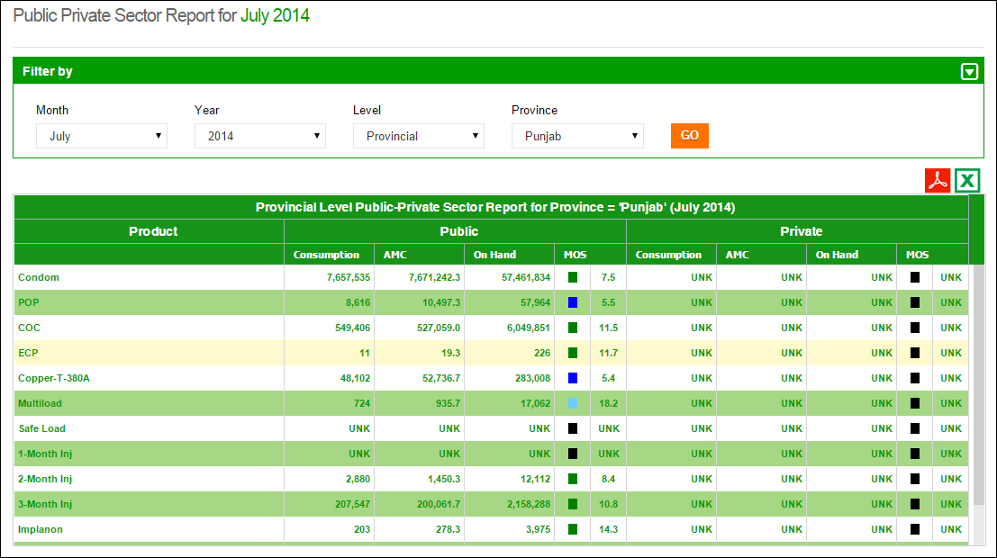

**Select Month &Year**

**Click GO**

**Select Level of Report**

|  |  |
| --- | --- |
| Maps | **6** |
| for Contraceptive Logistics Management Information System | | |

This chapter explains the step-by-step instructions on the map features that can be used by the Contraceptive Logistics Management Information system’s users.

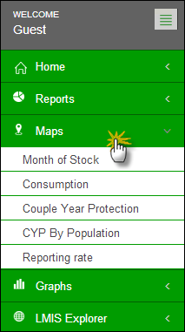The cLMIS also has the capability of generating easy to interpret maps with color codes. These maps can be viewed by selecting the “Maps” tab in the menu. The drop down menu will be displayed as follows:

Once the indicator for which the map is to be viewed is selected, the user will be directed towards a page to select from various filters.

### Month of Stock Map

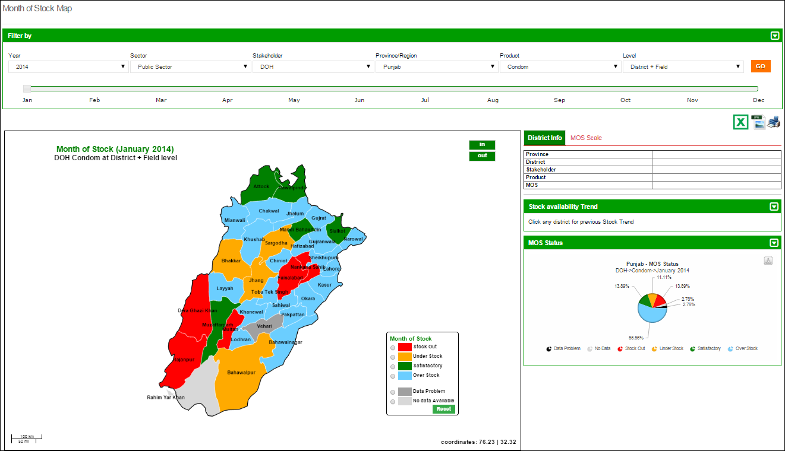Month of Stock (MOS) map provides many filter options to the user. User can select Month, Year, Province/Region, Product as well as Level to analyze MOS for each district in the selected province. The detailed information can be seen once the user clicks a particular district on the map.

**Select the Sector & Stakeholder**

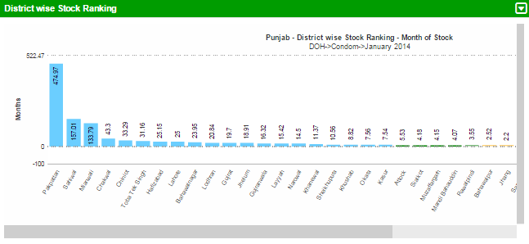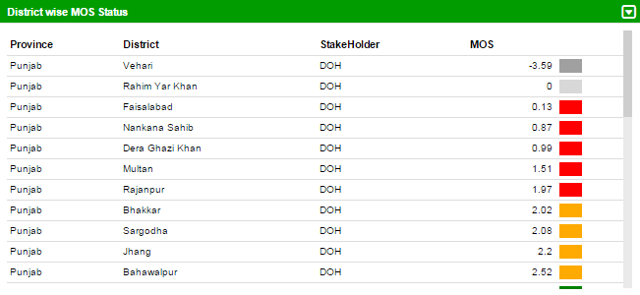

**Select the Province and Product**

**Select Year**

**Click GO**

### Consumption Map

Consumption map provides user with filter options such as Month, Year, Sector, Stakeholder, Province/Region, Product as well as Type (Consumption and Avg. Monthly Consumption) to analyze product consumption for each district in the selected province. The detailed information can be seen once the user clicks a particular district on the map.

**Select the Sector, Stakeholder & Province**

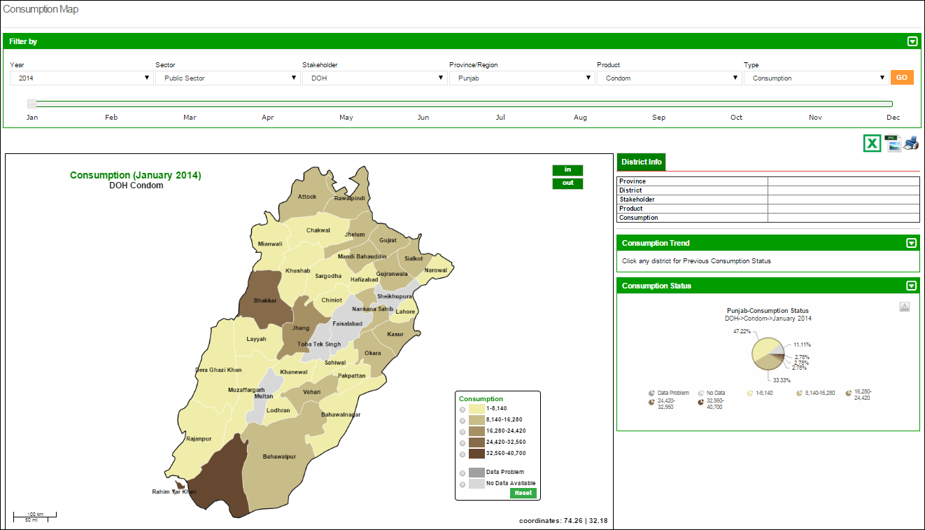

**Select the Product & Type**

**Select Year**

**Click GO**

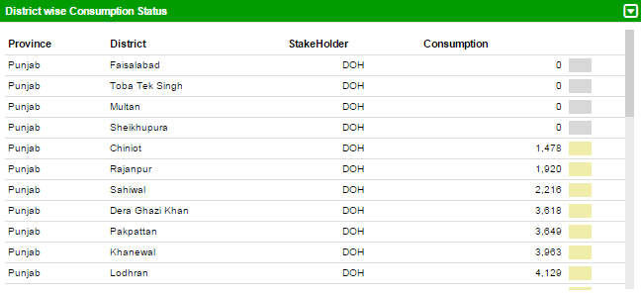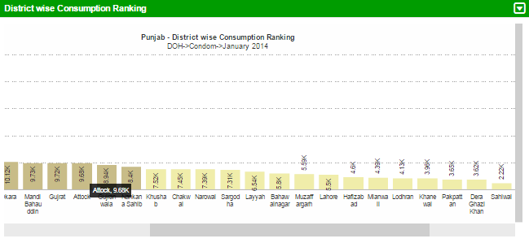

### Couple Year Protection Map

Couple Year Protection map provides user with filter options such as Month, Year, Sector, Stakeholder, Province/Region and Product to analyze number of couples protected for each district in the selected province. The detailed information can be seen once the user clicks a particular district on the map.

**Select the Sector & Stakeholder**

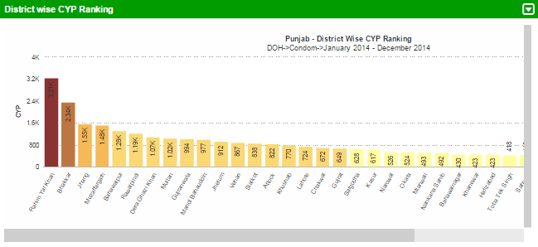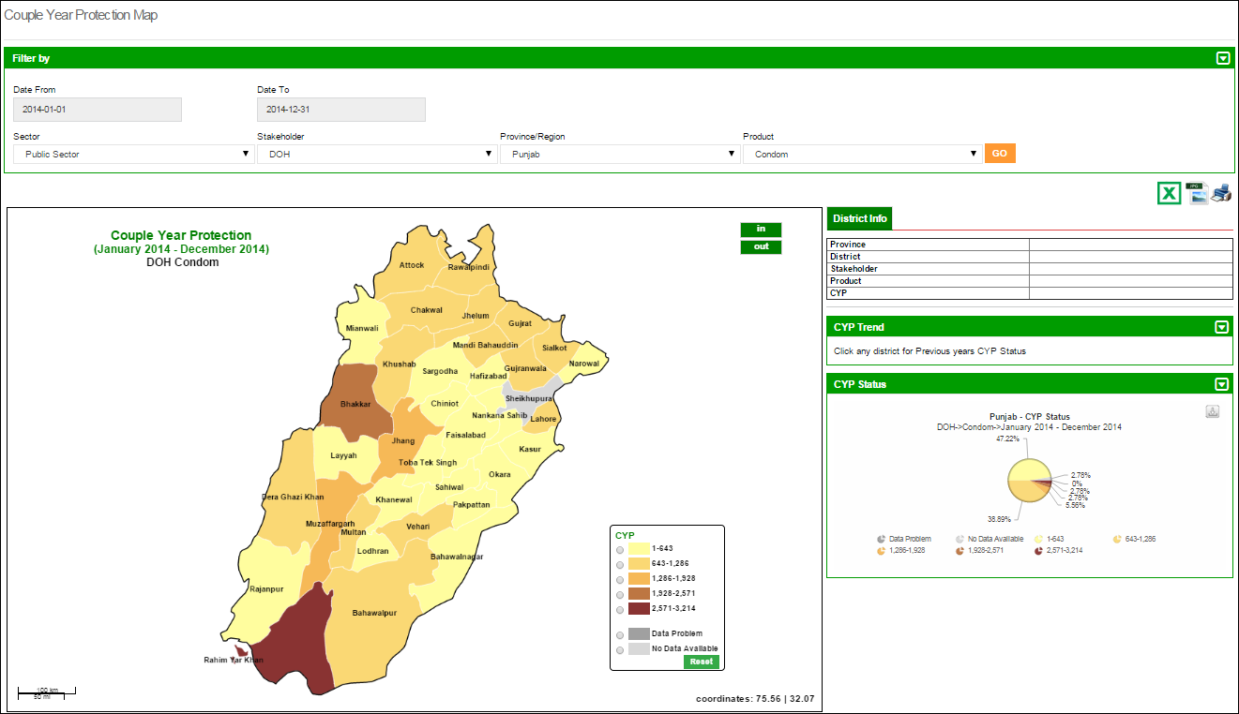

**Click a District on map to see details**

**Select the Province and Product**

**Select the Date From, To**

**Click GO**

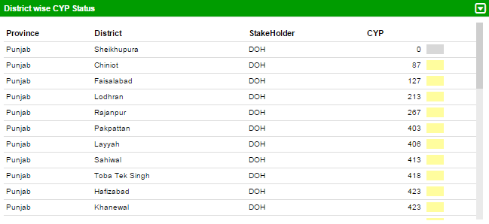

### CYP by Population Map

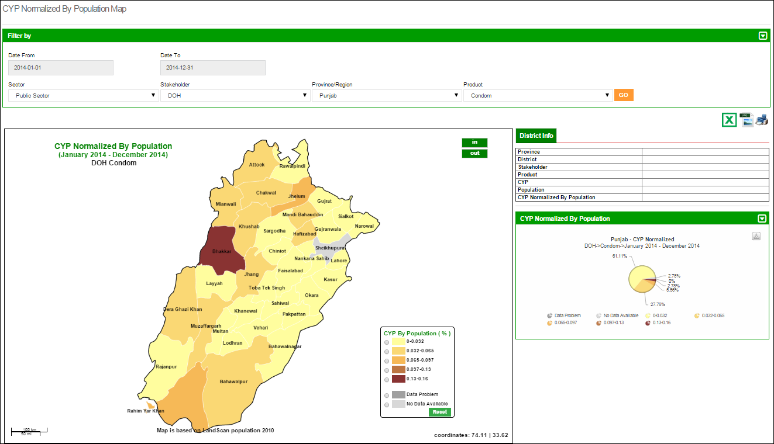Couple Year Protection map can also be normalized based on the population of the province. It provides user with filter options such as Month, Year, Sector, Stakeholder, Province/Region and Product to analyze number of couples protected for each district in the selected province based on the population of that district. The detailed information can be seen once the user clicks a particular district on the map.

**Click a District on map to see details**

**Select the Province and Product**

**Select the Date From, To**

**Select the Sector & Stakeholder**

**Click GO**

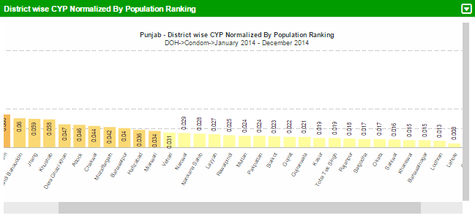

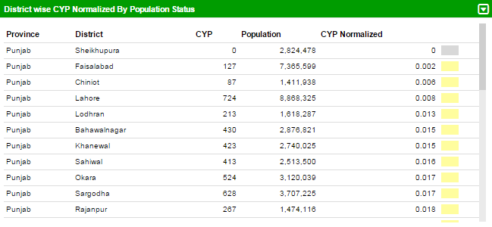

### Reporting Rate Map

Reporting rate map shows the number of stores and facilities which have provided the report for each district. User can see filter options such as Month, Year, Sector, Stakeholder, Province/Region and Product to analyze the reporting rate for each district in the selected province based on the number of facilities in that district. The detailed information can be seen once the user clicks a particular district on the map.

**Select the Sector & Stakeholder**

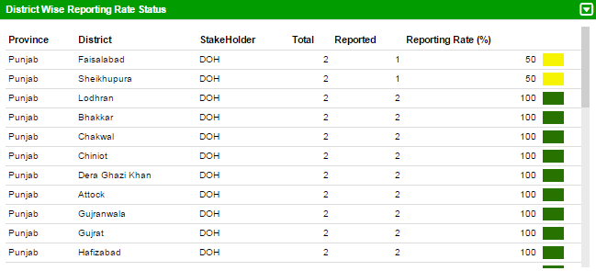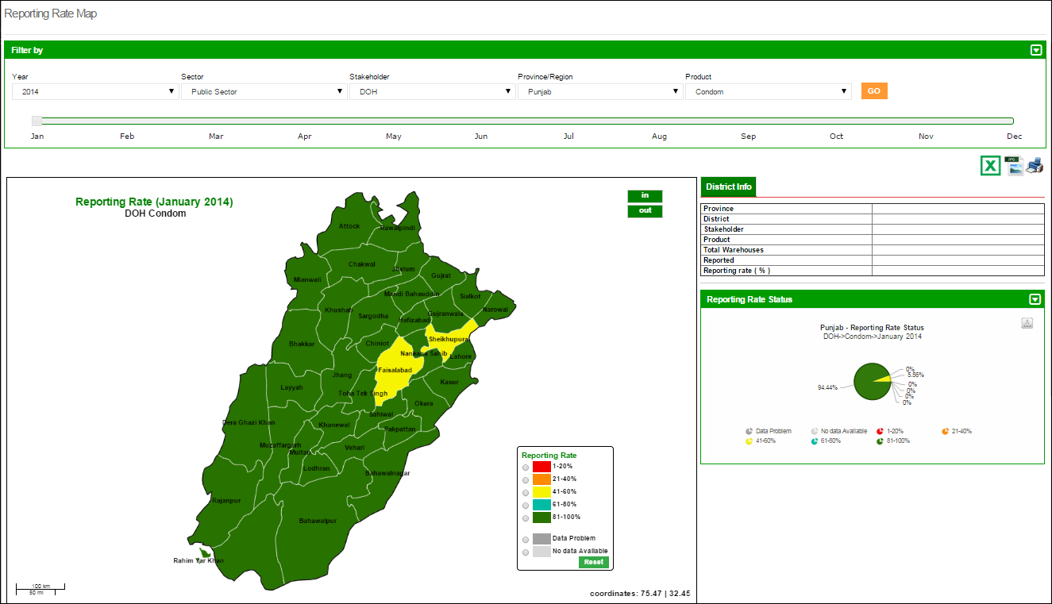

**Click a District on map to see details**

**Select the Province and Product**

**Select Year**

**Click GO**

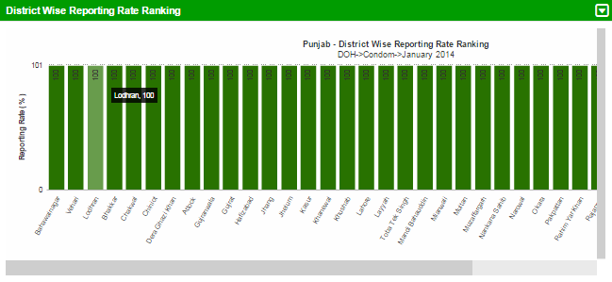

**Click GO**

|  |  |
| --- | --- |
| Graphs | **7** |
| for Contraceptive Logistics Management Information System | | |

This chapter explains the step-by-step instructions on the graph features that can be used by the Contraceptive Logistics Management Information system’s users.

The LMIS also has the capability of generating easy to interpret graphs. Simple and comparative graphs can be viewed by selecting the “Graphs” tab. The drop down menu will display:

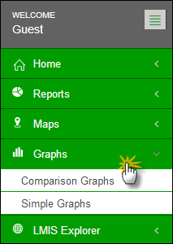

Once simple or comparison graphs is selected, the user is directed towards a page from where s/he can choose various options to create graphs.

### Comparison Graphs

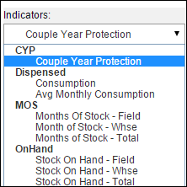Graph Comparison Report page includes different filters and select option to compare graphs to generate reports. Once the user clicks the ‘Indicators’, it gives four options to select from:

* + - * CYP (Couple Year Production)

**Select Indicators**

* + - * Dispensed
      * MOS(Month Of Stock)
      * On Hand

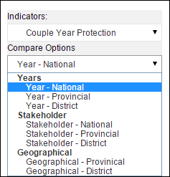Once user clicks the ‘Compare options’, it will give the user three options.

* + - * Years

**Select Comparison options of Years, Stakeholder and Geographical location**

* + - * Stakeholder
      * Geographical

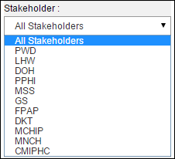Once the user clicks ‘Stakeholder’, it will show the list of all stakeholders to choose one.

**Select the Stakeholder**

Products and Year show multiple options to select. The user can choose more than one product and year respectively. By clicking on **Time-Interval** it shows three options:

* + - * 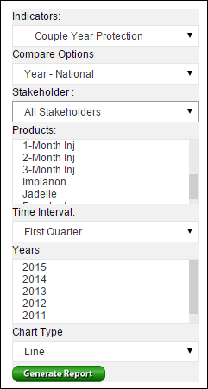Quarter

**Select comparison options**

* + - * Half
      * Annual

By clicking on Chart type it shows two options:

**Select multiple products for comparison**

* + - * Line Chart
      * Bar Chart

**Select time Intervals**

**After selecting all values, click here to generate report.**

**Select Line or Bar Chart**

#### Line Chart

**Click here to view graph in different formats such as PDF, JPG and PNG**

If the user selects line chart, it will generate graph like this:

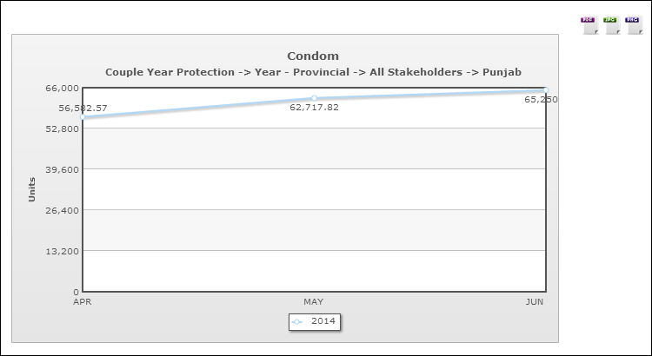

**Click here to view graph in different formats such as PDF, JPG and PNG**

#### Bar Chart

If the user selects bar chart, it will generate graph like this:

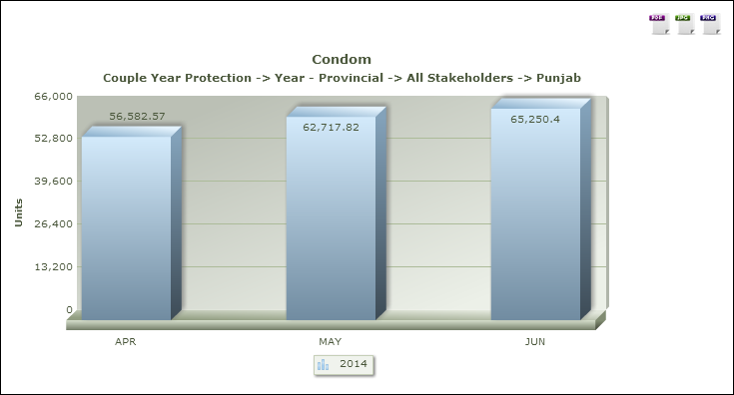

### Simple Graphs

**Click here to view graph in different formats such as PDF, JPG and PNG**

User can also choose the same filter options to create a simple graph.

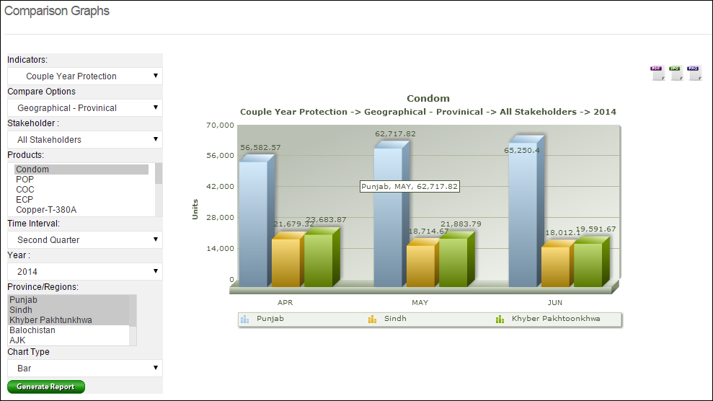

**Show the selected products data.**

|  |  |
| --- | --- |
| LMIS Explorer | **8** |
| for Contraceptive Logistics Management Information System | | |

This chapter explains the step-by-step instructions on the LMIS explorer features that can be used by the Contraceptive Logistics Management Information system’s users.

In LMIS explorer, the user can see monthly district warehouse or field store reports and data. If there is no data, a message will be shown.

**Click here to view report in different formats such as PDF and Excel**

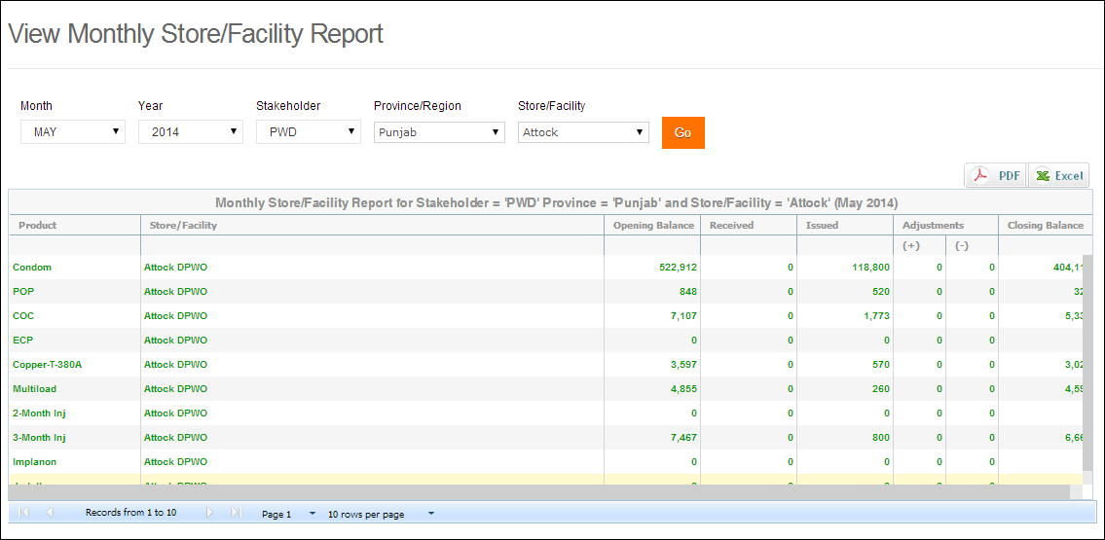

Similarly, the user can view monthly field reports and data. If there is no data for that selected field, it will show zeroes for that specific month.

|  |  |
| --- | --- |
| Guest User | **9** |
| for Contraceptive Logistics Management Information System | | |

This chapter explains the step-by-step instructions on the function and features that can be used by the Contraceptive Logistics Management Information system’s guest users.

The Contraceptive Logistics Management Information System enables you to login as a guest or anonymous user. Guest users can login into LMIS by entering username and password as ‘guest’. When a guest user enters login credentials, they can view analytical reports, maps, graphs and warehouse/district stores data report entered by stakeholder specific users for any period. However, they are not entitled to edit the data.

Logging into Guest user displays the following dashboard screen:  
 **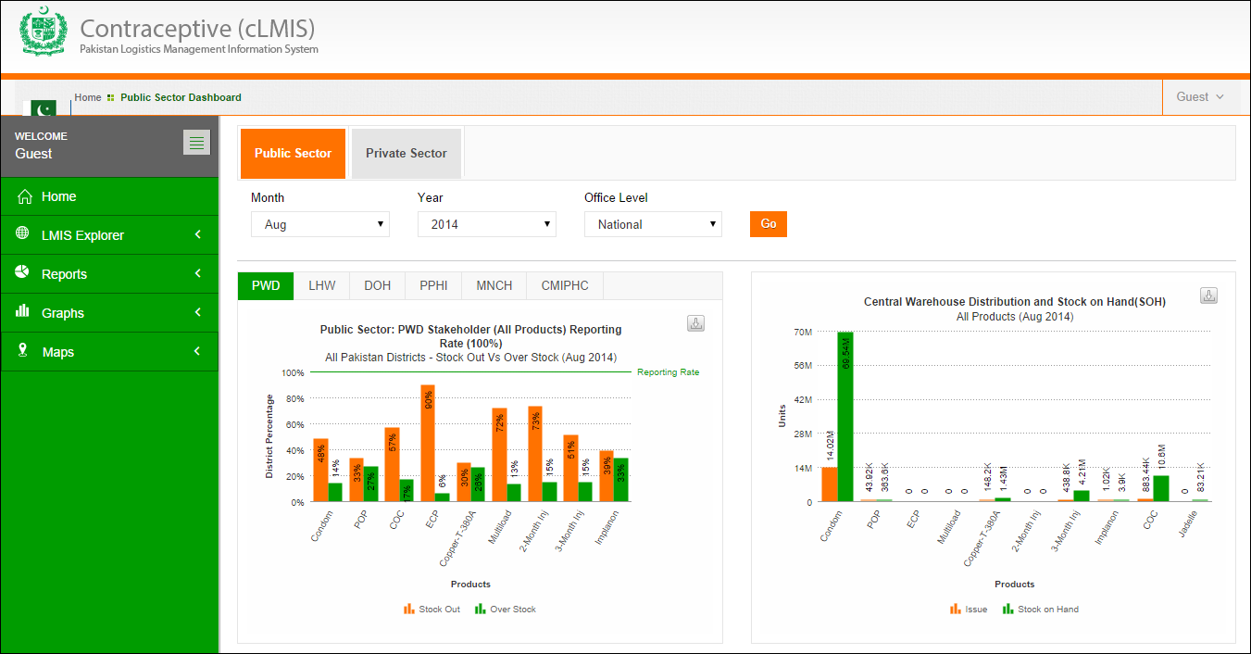**

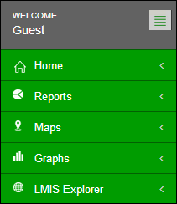On the left side of the dashboard screen, the guest user will see the following tabs:

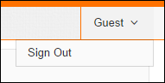**Guest**: User can sign out of the application by using the following link on the right side of the screen:

* **Dashboard**: User can view dashboards containing graphs, maps and analytical reports by using this tab.
* **Reports**: User can view analytical reports by using this tab.
* **Maps**: User can also view the analytical reports in the form of a map by using this link.
* **Graphs**: User can view simple and comparable graphs by using this link.
* **LMIS Explorer**: This link provide user to view individual warehouse / store data of a selected month.

|  |  |
| --- | --- |
| Authenticated Users - District | **10** |
| In Contraceptive Logistics Management Information System | |

This chapter explains overview of the authenticated users on the district level and describes the tasks they can perform while using Logistics Management Information System for contraceptives.

In order to log on to the system, the user will be allocated a username and password. Once successfully logged in, the user will be directed to a ‘user information’ page specific to the organization. This page will contain specific information about the user’s department or organization.

In order to obtain LMIS data and reports, the user must successfully login with his/her username and password. System users are defined by relevant stakeholders and the level in the supply chain they represent. For example, Population Welfare Department users work under Provincial PWD and District Population Welfare Officer.

After a successful login, the user will be directed to stakeholder specific page. Based on the privileges assigned to the user by the system administrator, various menu items will appear on the interface homepage.

After successful login, district user will see the following menu:

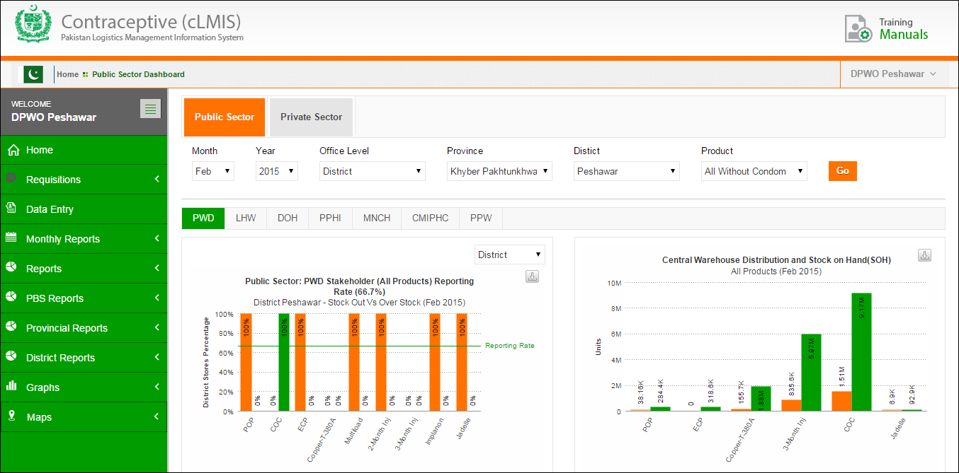

* **DPWO Peshawar**: Name of the User who is currently logged in.
* **Sign Out**: signs out the user to homepage of LMIS.
* **Change Password**: It allows user to change the password.
* 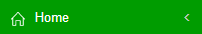: By clicking this icon, user will be reached on the dashboard page which appeared just after logging in.
* **Requisitions:** User can add or view requisition requests.
* **Data Entry**: User can enter monthly reports by using this menu item.
* **Monthly Reports**: User can view warehouse / stores reports by using this menu item.
* **Reports**: User can view pre-published analytical reports.
* **PBS Reports**: User can view the PBS reports.
* **Provincial Reports**: User can view the provincial level reports.
* **District Reports**: User can view the district level reports
* **Maps**: User can view analytical reports in the form of maps.
* **Graphs**: User can view pre-published graphs.

# Dashboard

Dashboard is a visual display of the most important analysis to achieve one or more objectives; consolidated and arranged on a single screen so the information can be viewed at a glance.

District user can view following dashboards by default:

* Public Sector Stakeholders
* Private Sector Stakeholders

Please refer to the **“Dashboards”** chapter above.

# Data Entry (Monthly Stock Consumption)

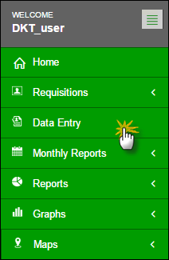In order to add monthly stock consumption report, click Data Entry tab from the main menu.

The facility data entry screen will be displayed. To enter consumption data for FWC, click **Add Report** in the FWC name row. (**FWC** **Achar** as shown in the screenshot)

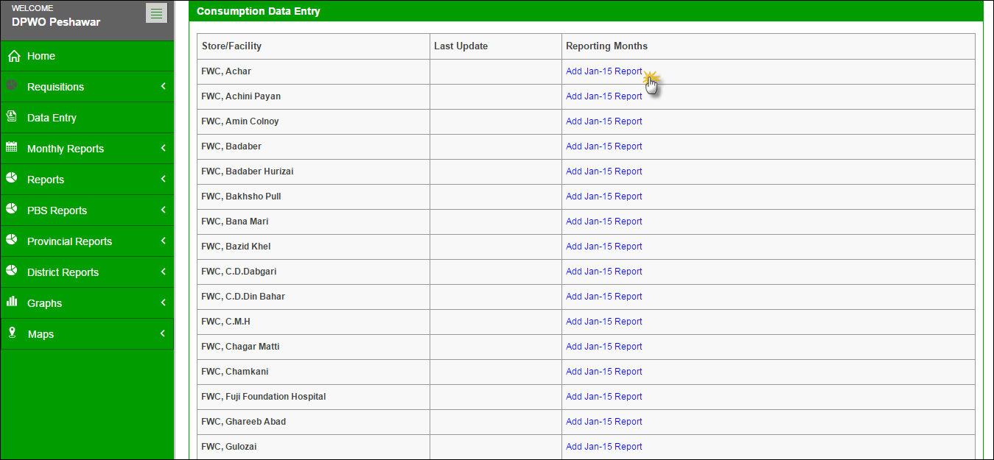

Click the Add Report option under the reporting month column. Once the user selects the Store/Facility and the month in which he/she wants to add data, a data entry screen will appear where the user can fill and save data for the reporting month.

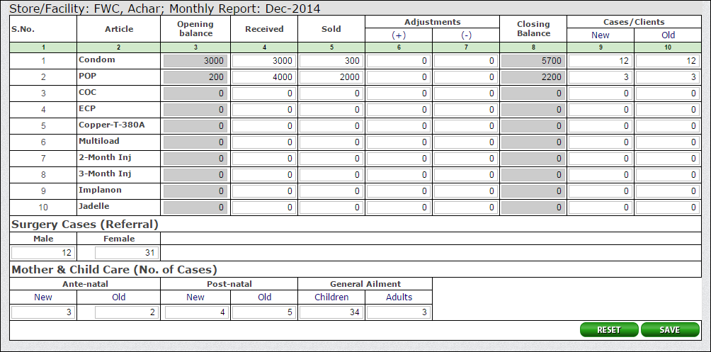

For PWD users, the data entry form shows additional fields which includes new and old cases or clients for each method.

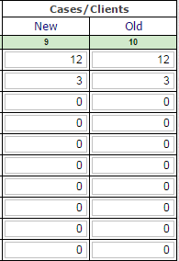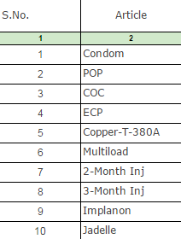

Other fields include:

* Surgery cases
* Ante-natal cases
* Post-natal cases
* General Ailment

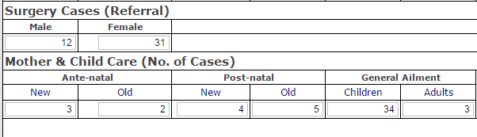

Enter the desired data within the form and click **Save.**

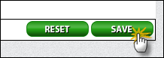

User can also click **Reset** to either undo or make the changes.

# Monthly Reports

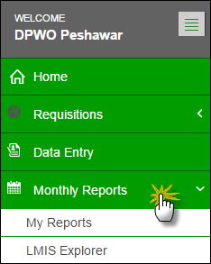District Users can view monthly reports of facilities / stores assigned to them as well as view reports of stores present in other districts.

### My Reports

User can view already reported reports by clicking “My Reports”. User can select any of his/her assigned facility /store to view data of that particular month.

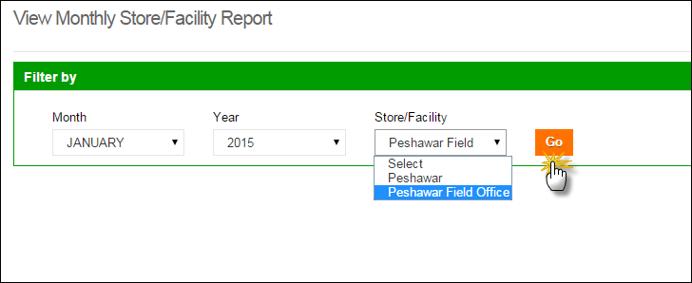

User can now view the report for the selected month. 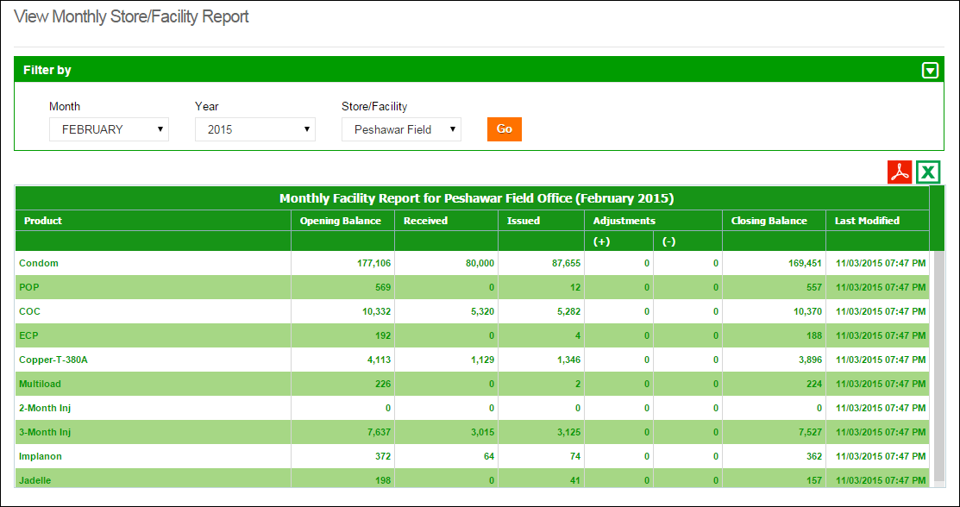

**Select Month, Year and Facility**

**Click Go**

### LMIS Explorer

User can also view already reported reports from other warehouses by clicking “LMIS Explorer”. User can select any of the stores / facilities in a district to view data of a particular month.

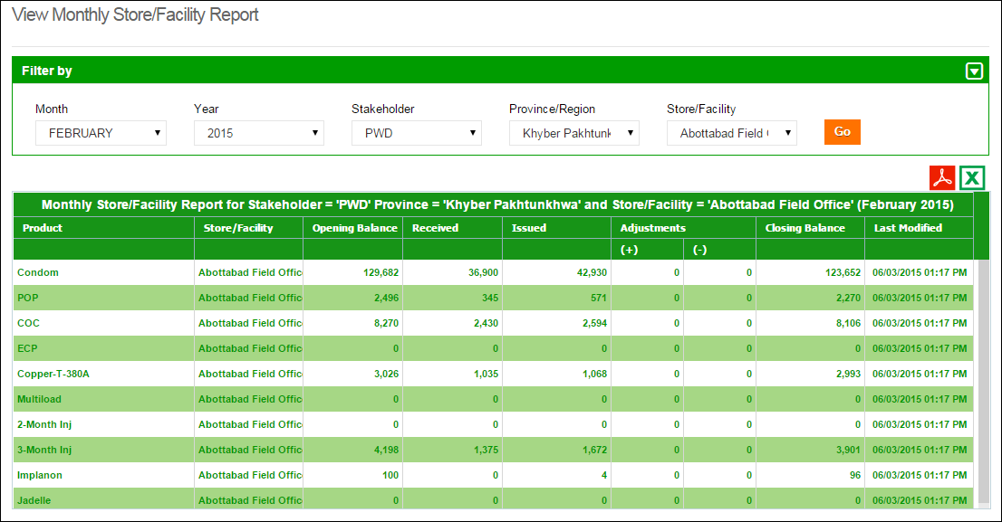

**Click Go**

**Select the Filters**

# Requisitions

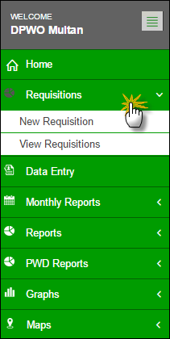Stock Requisition form is being used by EDO (H) for commodities request from CW&S. EDO (H) staff prepares this requisition form on quarterly basis in consultation with storekeeper of DPWO. This form indicates the stock status and consumption during the quarter and indicates the quantity request for each contraceptive being used in respective districts.

The district store users were required to fill out Requisition (CLR-6) based on the previous consumption of that district and submit to the Central Warehouse. However, in Release-2 of cLMIS, Requisition (CLR-6) is auto generated using previous consumption trends for the required quantity of products for the next quarter.

**Central Warehouse**

**Send a Requisition**

**Issue Stock against each Requisition**

### New Requisition

New Requisition (CLR-6) auto-fills the fields by using previous consumption data of a district in a selected quarter. This sheet was previously filled by the requester. District user can create requisition and electronically submit it to the central warehouse. These requisitions will be reviewed by the management of central warehouse and stock will be issued as per stock availability and approval.

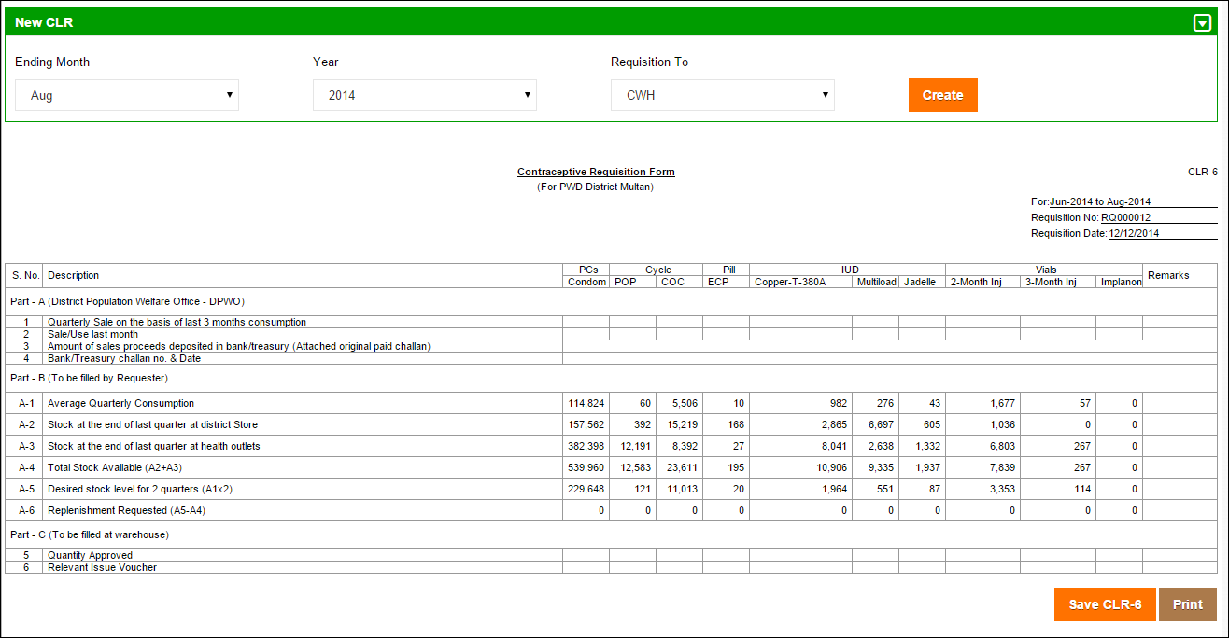

Click **Save CLR-6** or **Print.**

### View Requisition

District users can also view a comprehensive list of requisition requests placed to the central warehouses. Details of each requisition will also be available for District users to view.

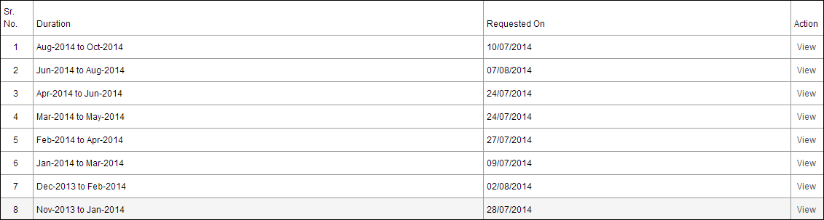

Submitted Requisition (CLR-6) can be viewed any time by the requester.

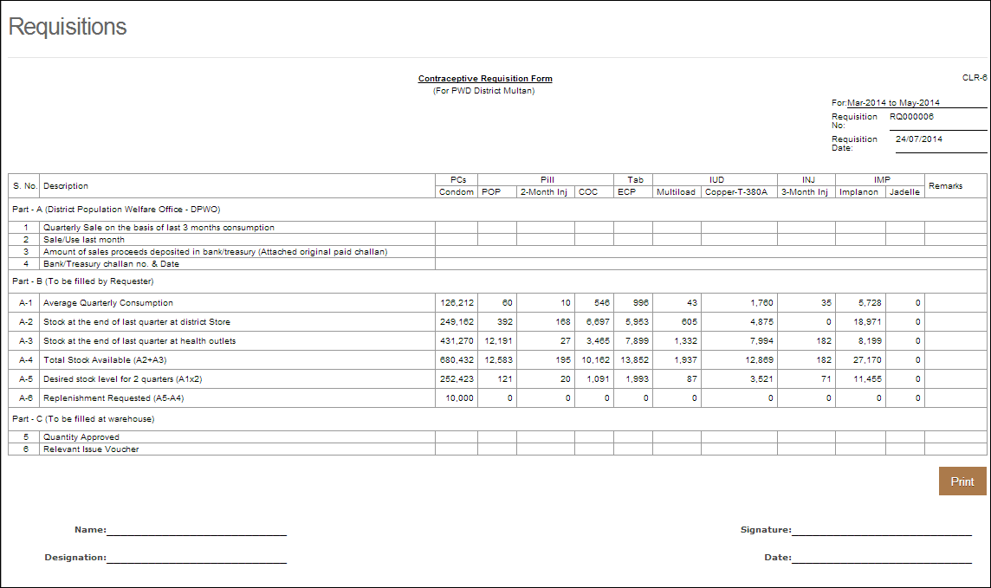

# PBS Reports

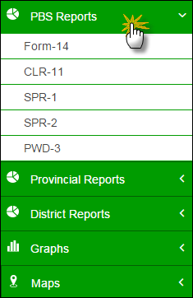When a user clicks the **PBS Reports** tab, the application shows the list of all available reports for PBS. These reports include Provincial level Reports for all methods such as Form-14, CLR-11, Sales Performance Reports (SPR-1 and 2) and PWD-3 Report.

Click the **PBS Reports** tab from the main menu to show a drop down list:

### Form - 14

Form -14 is the provincial summary report for contraceptive performance delivery services at the service outlets. It shows the report for all methods with the name of service outlet as well as the number of outlets in the selected province.

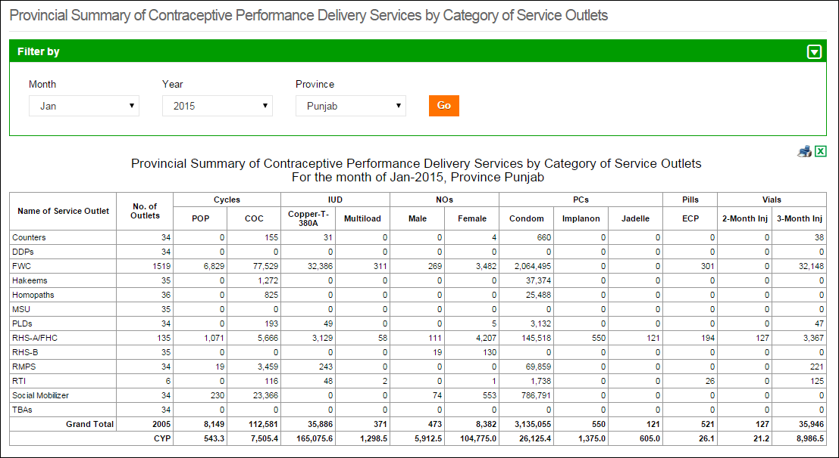

**Use Filter options to filter data in the table below**

### CLR - 11

CLR – 11 is a district-wise stock and sales report for the selected province and product. It shows the list of districts along-with the stock and sales reports for district and field stores as well as all health facility types (FHC, FWC, etc.) in the selected province.

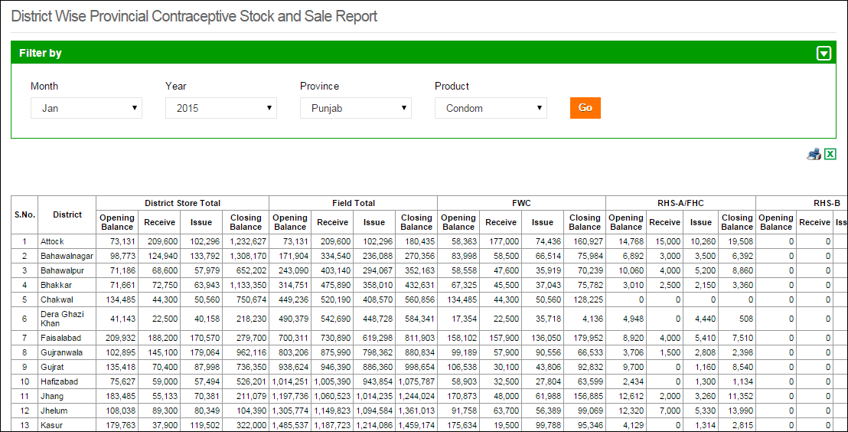

**Use Filter options to filter data in the table below**

### SPR - 1

SPR - 1 is the Sales Performance Report – 1 for male, female and total clients for contraceptive surgeries in each district. It shows the client-based report in RHS-A, RHS-B and the sum of both centers.

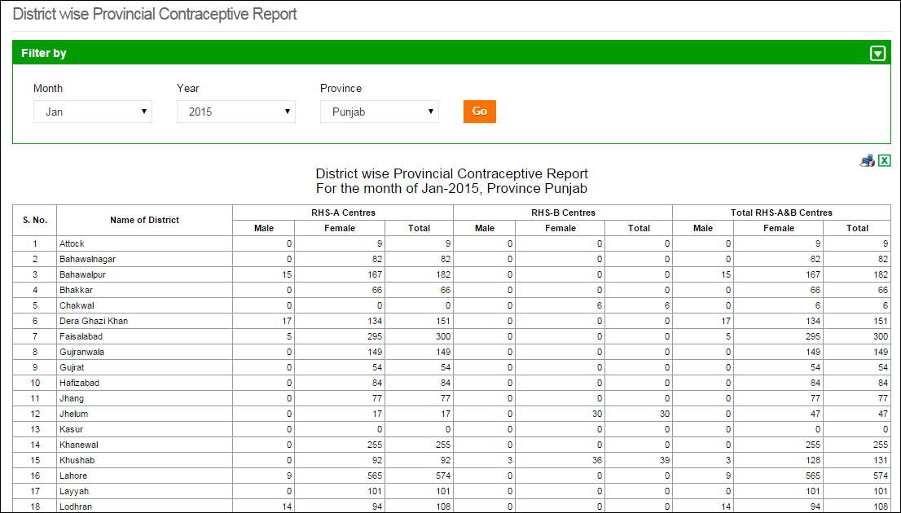

**Use Filter options to filter data in the table below**

### SPR - 2

SPR - 2 is the Sales Performance Report – 2 for new and old clients at the provincial level. It shows the client-based report for all methods in all health facilities in all districts of the selected province.

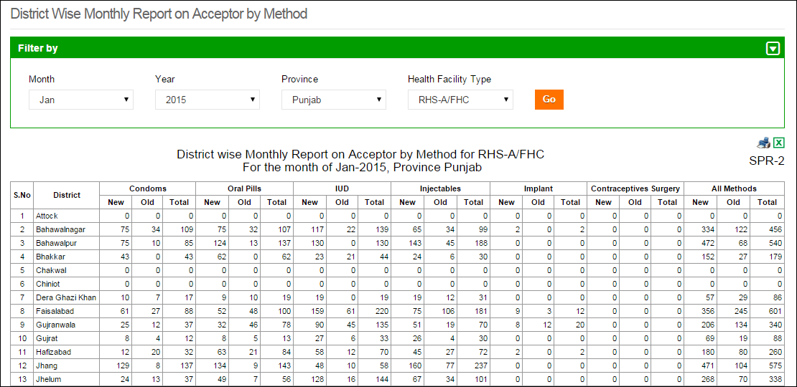

**Use Filter options to filter data in the table below**

### PWD - 3

PWD – 3 is a district-wise monthly report based on methods used. It shows number of new and old cases (pre-natal and post-natal) and general ailments treated in the list of district at the selected province.

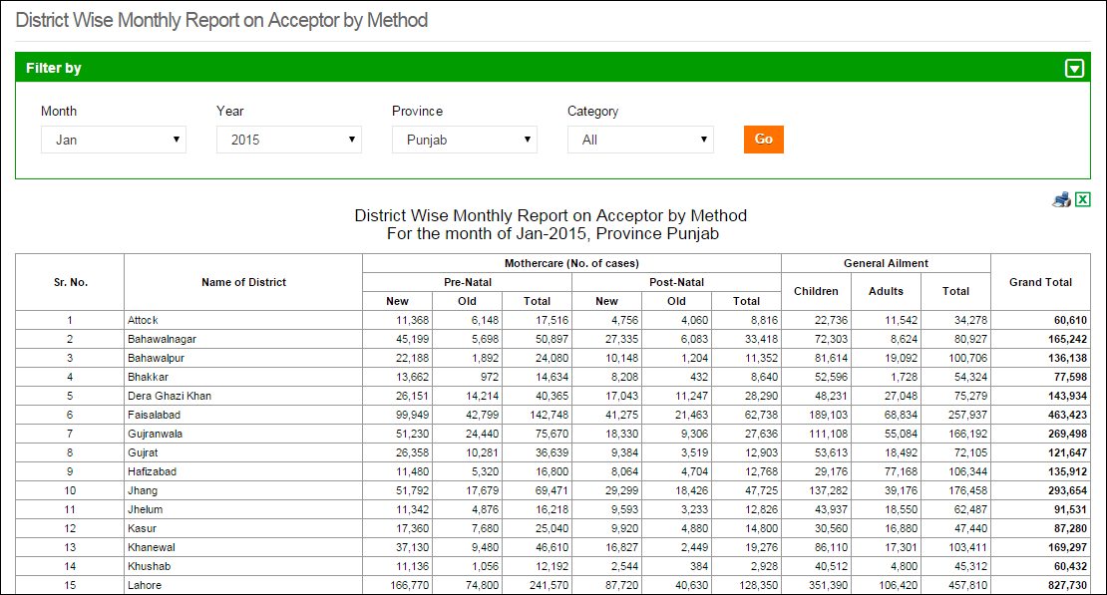

**Use Filter options to filter data in the table below**

# Provincial Reports

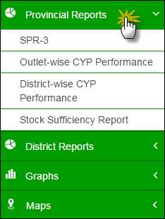When a user clicks the **Provincial Reports** tab, the application shows the list of all available reports at the provincial level. These reports include Provincial level Reports for all methods such as SPR-3, outlet and district-wise CYP performance and stock sufficiency report.

Click the **Provincial Reports** tab from the main menu to show a drop down list:

### SPR - 3

SPR - 3 is the Sales Performance Report – 3 based on the performance (the number of methods sold) at the provincial level. It shows the performance-based report for all methods in all health facilities in all districts of the selected province.

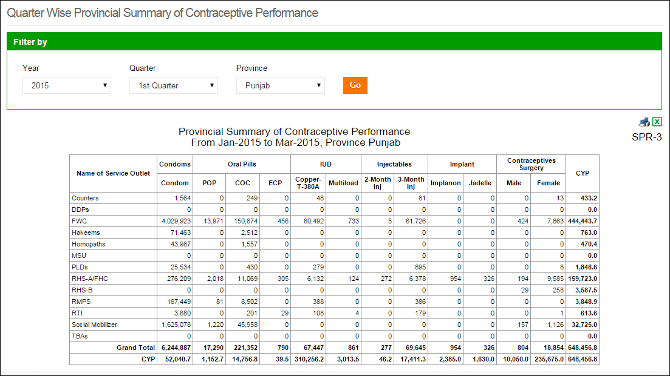

**Use Filter options to filter data in the table below**

### Outlet-wise CYP Performance

Outlet-wise CYP Performance report is the comparison of performance (in terms of CYP) in the selected month and previous month for one selected province. It shows the list of outlets, CYP for two consecutive months and the calculated as well as percentage increase/decrease in the CYP during these months.

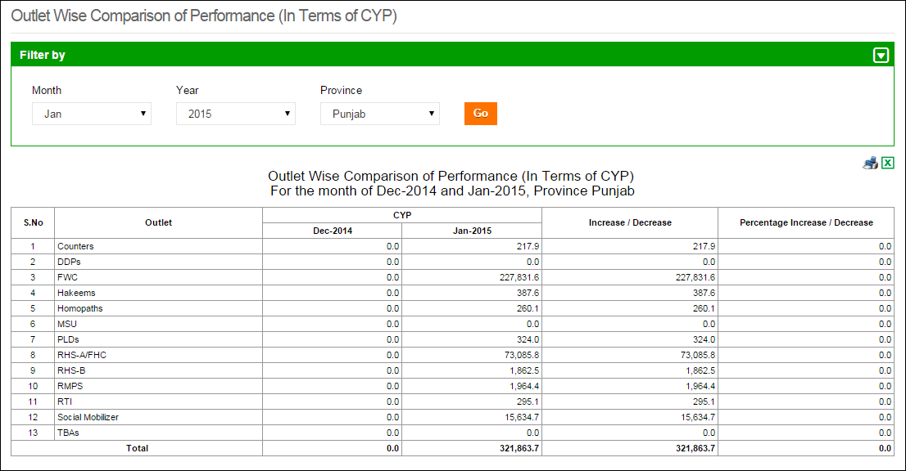

**Use Filter options to filter data in the table below**

### District-wise CYP Performance

District-wise CYP Performance report is the comparison of performance (in terms of CYP) in the selected month and previous month for one selected province. It shows the list of districts in the selected province, CYP for two consecutive months and the calculated as well as percentage increase/decrease in the CYP during these months.

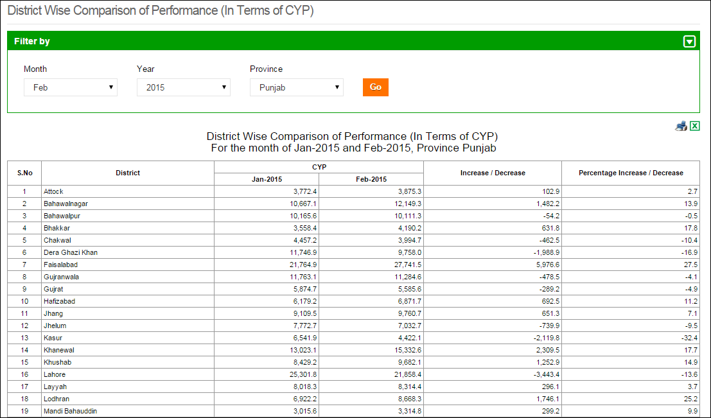

**Use Filter options to filter data in the table below**

### Stock Sufficiency Report

Stock sufficiency report is the provincial level report for stock for each month. It shows the list of districts in the selected province and district, field, and total MOS for all methods in each district.

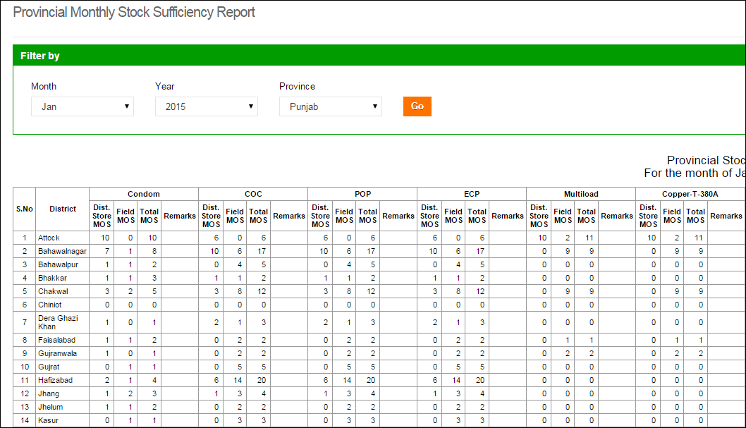

**Use Filter options to filter data in the table below**

# District Reports

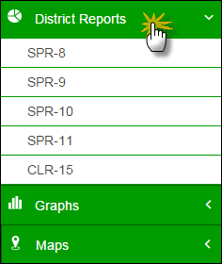When a user clicks the **District Reports** tab, the application shows the list of all available reports at the district level. These reports include Provincial level Reports for all methods such as SPR-8, SPR-9, SPR-10, SPR-11 and CLR-15.

Click the **District Reports** tab from the main menu to show a drop down list:

### SPR - 8

SPR – 8 is the Sales Performance Report – 8 for new and old clients at the district level. It shows the client-based report for all methods in all health facilities in the selected district of the selected province.

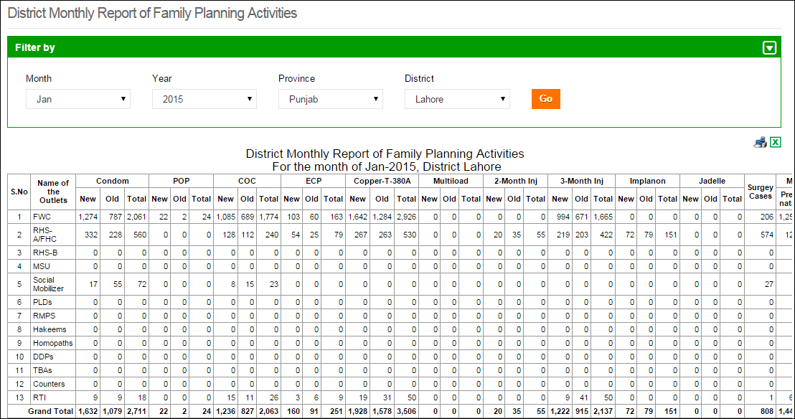

**Use Filter options to filter data in the table below**

### SPR - 9

SPR - 9 is the Sales Performance Report – 9 based on the performance (the number of methods sold) at the district level. It shows the performance-based report for all methods in all health facilities in the selected district of the selected province.

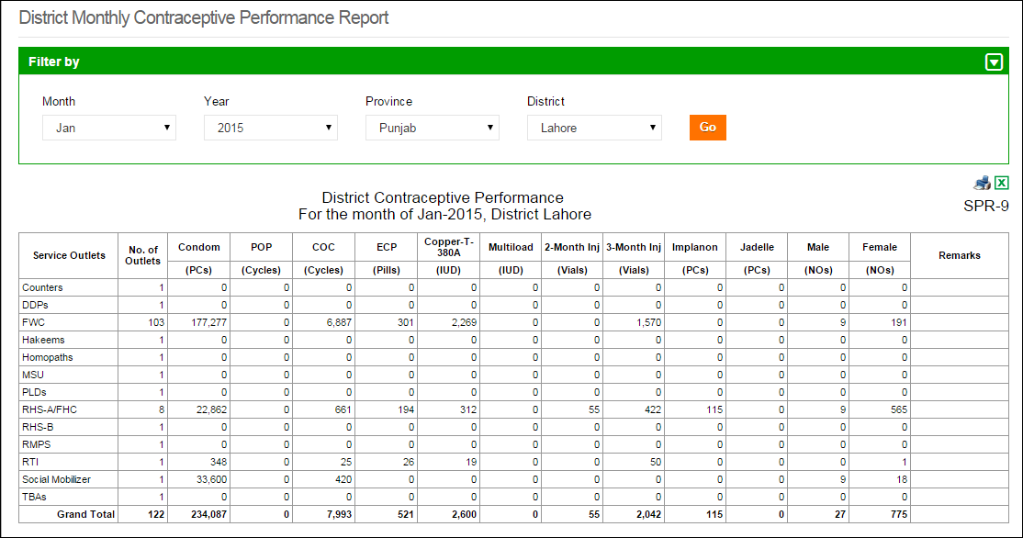

**Use Filter options to filter data in the table below**

### SPR - 10

SPR - 10 is the Sales Performance Report – 10 based on the performance (the number of methods sold) at the health facility level in a selected district. It shows the performance-based report (including CYP) for all methods using health facility type (FHC, FWC, etc.) in the selected district of the selected province.

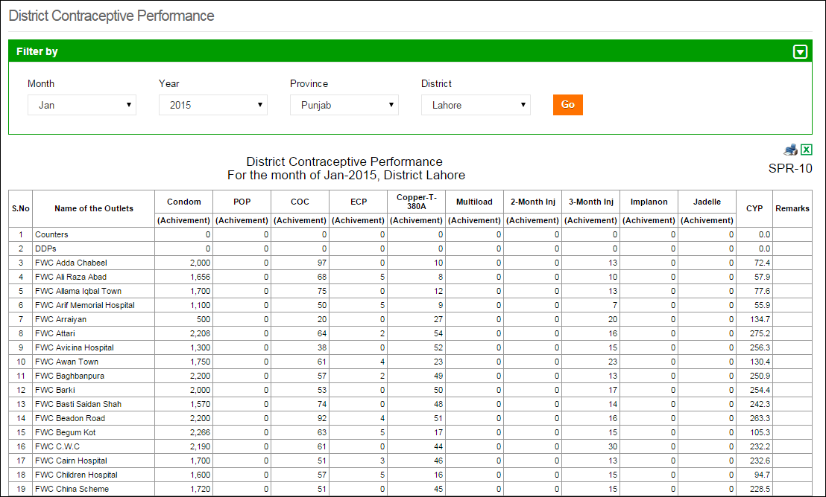

**Use Filter options to filter data in the table below**

### SPR - 11

SPR - 11 is the Sales Performance Report – 11 based on the performance (the number of methods sold) at the health facility level in a selected district. It shows the performance-based report for all methods (including surgery cases) using health facility type (FHC, FWC, etc.) in the selected district of the selected province.

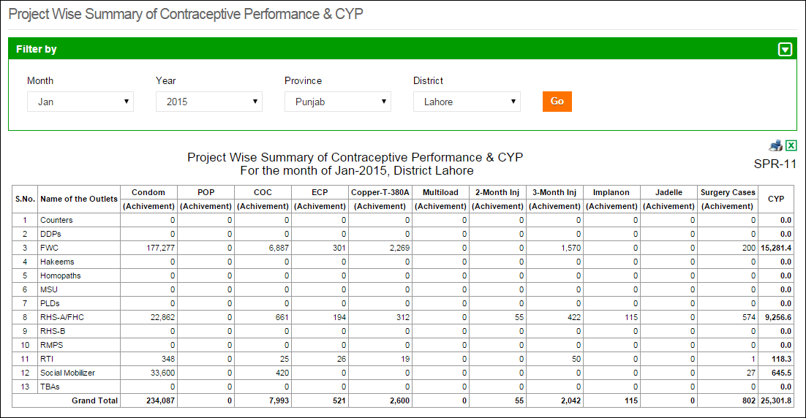

**Use Filter options to filter data in the table below**

### CLR - 15

CLR – 15 is a stock report for the selected province and district for all methods (including contraceptive surgeries) at the store and field level. It shows the stock report at the district store and field in detail for all methods and contraceptive surgeries in all health facility types i.e. FHC, FWC, etc.

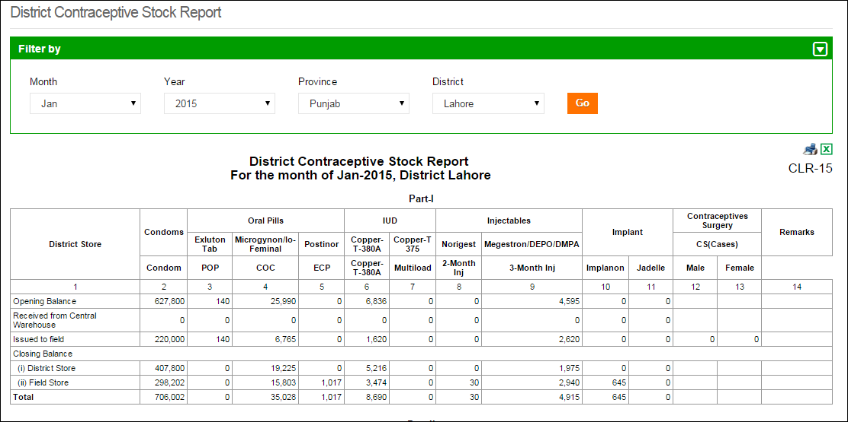

**Use Filter options to filter data in the table below**

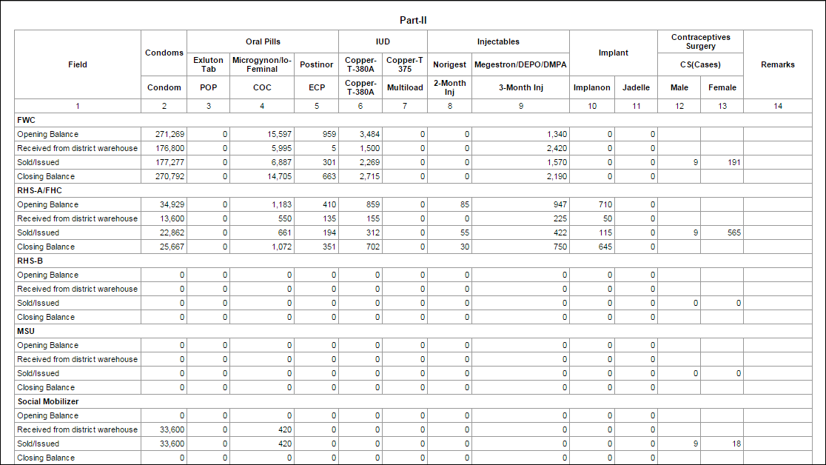

# Reports

When a user clicks the **Reports** tab, the application shows the list of all available reports. These reports include National, Provincial and District level Reports of both public and private sectors. It also includes Stakeholder Reports, Summary Reports, Field Reports and Stock Availability Reports. Quarterly and Provincial Reporting Rate has also been added in the list of available reports.

Please refer to the “Reports” chapter above.

# Maps

The cLMIS also has the capability of generating easy to interpret maps with color codes. These maps can be viewed by selecting the “Maps” tab in the menu. Once the indicator for which the map is to be viewed is selected, the user will be directed towards a page to select from various filters.

Please refer to the “Maps” chapter above.

# Graphs

The LMIS also has the capability of generating easy to interpret graphs. Simple and comparative graphs can be viewed by selecting the “Graphs” tab. Once simple or comparison graphs is selected, the user is directed towards a page from where s/he can choose various options to create graphs.

Please refer to the “Graphs” chapter above.

